

Career Dao

A degital job solution for you

Supervised by

Md Shohel Arman

lecturer

Depratment of Software Engineering

Daffodil International University

Submitted By

Abu Sayeed Md Iqbal majumder

Id: 181-35-2308

Department of Software Engineering

Daffodil iNternaitnoal University

2022

Declaration

I hereby declare that I have done this project under the supervision of Md Shohel Arman, lecturer of Department of Software Engineering. Any part of this project is unique and developed by myself. This project has not been submitted elsewhere.

_______________________________

Abu Sayeed Md Iqbal Majumder

181-35-2308

Department of Software Engineering

Daffodil International University

Certified By:

______________________________

Md Shohel Arman

Lecturer

Department of Software Engineering

Daffodil International University

Acknowledgement

I am thankful to almighty I have reached this far in my university life. Lots of friends and teacher always motivated me to do something great. I gave got lots of help and guidelines for this project by my supervisor. I am very thankful for that.

Abstract

In this subcontinental region, there is no such famous platform where people can do job whatever type he/she want. Though there are some famous platforms for freelancing, they do not offer all sort of features that I am trying to offer and this will be a very much positive for the fresher who are searching for job according to their choice. The purpose of this documentation is to introduce Cakribazar web platform which is a concept of two-sided web platform where one is those who want job and another one is those who will provide job. These jobs can be remote or project based or offline job.

Table of Contents

Chapter 1: Introduction 11

1.1. Project title Cakribazar 11

1.2. Idea 11

1.3. Motivation 11

1.4. Goals of the project 11

1.5. Scope: 11

1.6. Overview 12

1.7. Glossary 12

1.8. Project Planning 13

2.1. Functional Requirements: 14

**2.2.** Non-functional requirements: 15

2.3. User characteristics 15

2.4. System Requirement Specification 16

2.4.1. Authentication 16

2.4.2. Logout 16

2.4.3. Company profile 17

2.4.4. Company profile edit 17

2.4.5. Project manager profile 17

2.4.6. Project manager profile edit 17

2.4.7. Employee profile 18

2.4.8. Employee profile edit 18

2.4.9. Job list 18

2.4.10. Project list 18

2.4.11. Job details 19

2.4.12. Project details 19

2.4.13. Featured Job list 19

2.4.14. Featured Project list 19

2.4.15. Job applies 20

2.4.16. Project applies 20

2.4.17. Employee resume 20

2.4.18. Company info 20

2.4.19. Project manager detail 21

2.4.20. Community 21

2.4.21. Create community 21

2.4.22. Post in community 21

2.4.23. Live message 22

2.4.24. FAQ 22

2.4.25. Notification 22

2.4.26. Applied list 22

2.4.27. Apply detail 23

2.4.28. Popular fields 23

2.4.29. Approve company, project manager & employee 23

2.4.30. Report 23

2.4.31. Ban company, project manager & employee 24

2.4.32. Approve job, project 24

2.5. Non-functional requirements: 24

2.5.1. Landing page 24

2.5.2. Filtering 24

2.5.3. Bookmark 25

2.5.4. Remote desktop 25

2.5.5. Security 25

2.5.6. Accessibility 25

2.5.7. Availability 25

2.5.8. Confidentiality 26

2.5.9. Efficiency 26

2.5.10. Reliability 26

2.5.11. Safety 26

2.5.12. Survivability 26

2.5.13. Usability 27

2.5.14. Trash box 27

3.2. Use case 29

3.3. Generalize Use Case 30

3.3.1. Use case: 30

3.3.2. Use Case: 31

3.3.3. Use Case: 33

3.3.4. Use Case: 34

3.3.5. Use Case: 35

3.3.6. Use Case: 36

3.4. Use Case Flow, Stakeholder, Conditions 37

3.4.1. Authentication 37

3.4.2. Logout 38

3.4.3. Company profile 38

3.4.4. Company profile edit 38

3.4.5. Project manager profile 39

3.4.6. Project manager profile edit 39

3.4.7. Employee profile 39

3.4.8. Employee profile edit 40

3.4.9. Job list 40

3.4.10. Project list 40

3.4.11. Job details 41

3.4.12. Project details 41

3.4.13. Featured Job list 41

3.4.14. Featured Project list 42

3.4.15. Job applies 42

3.4.16. Project applies 42

3.4.17. Employee resume 43

3.4.18. Company info 43

3.4.19. Project manager detail 43

3.4.20. Community 44

3.4.21. Create community 44

3.4.22. Post in community 44

3.4.23. Live message 45

3.4.24. FAQ 45

3.4.25. Notification 45

3.4.26. Applied list 46

3.4.27. Apply detail 46

3.4.28. Popular fields 46

3.4.29. Approve company, project manager & employee 47

3.4.30. Report 47

3.4.31. Ban company, project manager & employee 47

3.4.32. Approve job, project 48

3.4.33. Bookmark 48

3.4.34. Remote desktop 48

3.5. Activity Diagram 49

3.5.1. Authentication 49

3.5.2. Logout 50

3.5.3. Post new job 51

3.5.4. Post new project 52

3.5.5. Job list 53

3.5.6. Project list 54

3.5.7. Apply Job 55

3.5.8. Apply Project 56

3.5.9. Applied list 57

3.5.10. Profile section 58

3.5.11. Submitting comment 59

3.5.12. Creating and updating resume 60

3.5.13. Creating community 61

3.5.14. Joining Community 62

3.5.15. Post in community 63

3.5.16. Live messaging 64

3.5.17. Remote support 65

3.5.18. Online meeting 65

3.5.19. Manage projects, jobs, applied list 66

3.5.20. See popular jobs 67

3.5.21. Verify company 68

3.5.22. Verify Project manager 69

3.5.23. Verify jobs 70

3.5.24. Verify projects 71

3.6. Sequence Diagram 72

3.6.1. Sign Up 72

3.6.2. Sign In 73

3.6.3. Log out 74

3.6.4. Post a job 75

3.6.5. Post a project 76

3.6.6. Job list 77

3.6.7. Project list 78

3.6.8. Apply job 79

3.6.9. Apply project 80

3.6.10. Create new community 81

3.6.11. Edit details 82

3.6.12. Remote facilities 83

3.6.13. Online meeting 84

3.6.14. Rating & review 85

3.6.15. Applied list 86

3.6.16. Join community 87

3.6.17. Post in community 88

3.6.18. Resume 89

3.6.19. Manage Company 90

3.6.20. Manage project manager 91

3.6.21. Manage job 92

3.6.22. Manage project 93

3.6.23. Statistics 94

3.6.24. Popular fields 95

3.6.25. Transaction list 96

3.6.26. Resume 97

3.7. Entity Relationship Diagram 98

3.7.1. Full diagram 98

3.7.2. Normalize ER Diagram 99

3.7.2.1. Part-1 99

3.7.2.2. Part-2 100

3.7.2.3. Part-3 100

CHAPTER 4: System Testing 101

4.1. Introduction 101

4.2. Feature to be Tested 101

4.3. Test Case 102

4.3.1. Sign up 102

4.3.2. Sign in 102

4.3.3. Post job 103

4.3.4. Manage Profile 103

4.3.5. Apply job 104

4.1.1. Create community 104

4.1.2. Log out 104

Chapter 5: Application UI & User Manual 105

5.1. Authentication 105

5.2. Landing page 105

5.3. Popular categories 106

5.4. Featured Jobs 106

5.5. Post a job 107

5.6. Job list 107

5.7. Live messaging 108

Chapter 6: Conclusion 109

6.1. Limitations 109

6.2. Obstacles 109

6.3. Achievement 109

6.4. Future Scope 109

6.5. Reference 109

6.5.1. Upwork 109

6.5.2. Fiverr 109

6.5.3. PeoplePerHour 110

6.5.4. Naukri.com 110

6.5.5. Bdjobs.com 110

# Chapter 1: Introduction

# Project title Cakribazar

# Idea

This is an web application named Cakribazar. This application is committed to improving the quality of life of unemployed people at technical levels. This where people can find job without any third party bothering. Application like Bdjobs, Chakuri are third party for applying any job but here one kind of people can post any job if he/she/company needed and the other one will apply through this application and can get hired.

# Motivation

Human society is constantly working tirelessly for the progress of human civilization and the improvement of human life. Agreeing with this effort, so many freelancers from our country are working on platform like Fiverr, Upwork freelancer etc. and this platform are charging from them for their service. Again, some third party are harassing unemployed people for job and charging huge money and got cheated by those party. So I thought If I could build a platform where our people can get their proper job solution even online or offline which could save huge money which are going to those foreign company and also people will not get harassed for job and any kind of blackmailing may not happen in future.

# Goals of the project

The goal of this web application is digitalizing Bangladesh and reducing unemployment. By this application we can also save our money. By creating an account user can post job or search for a job and contact directly with the job provider so that we should not depend on third party application who submit our CV to company. User can do freelancing on project basis work as well as job. With a simple user interface user from every sector can handle this application.

# Scope:

Considering the overall system and features this application is meant to offer a easier and smart lifestyle by providing one a correct job profile. This will less one’s harassed and make his/her perfect for his/her right job.

Again, if we think from the perspective of our country, we can save a lot on money by using this system. Our financial structure can be more effective if everyone gets the correct option.

# Overview

* + 1. This is an web application named CareerDao
    2. This where people can find job without any third party bothering
    3. Here, one kind of people can post any job if it needed and the other one will apply through this application and can get hired
    4. All can have online meeting through this site to report about each job or project
    5. By saving a huge amount of money, this application can contribute to our GDP
    6. This can digitalize out appointing system
    7. Each job and project will have a record which will reduce internal corruption

# Glossary

Here are some keywords that I used in this paper. Going through this will help you to understand those terms.

|  |  |  |
| --- | --- | --- |
| Sl no | Term | Definition |
| Term-01 | Stakeholder | A stakeholder is a party that has an interest in a company and can either affect or be affected by the business. The primary stakeholders in a typical corporation are its investors, employees, customers, and suppliers. |
| Term-02 | End-User | In product development, an end user (sometimes end-user) is a person who ultimately uses or is intended to ultimately use a product. |
| Term-03 | Administrator | An Administrator provides office support to either an individual or team and is vital for the smooth-running of a business. Their duties may include fielding telephone calls, receiving and directing visitors, word processing, creating spreadsheets and presentations, and filing. |
| Term-04 | Use Case | A use case is a written description of how users will perform tasks on your website. It outlines, from a user's point of view, a system's behavior as it responds to a request. |
| Term-05 | SRS | A software requirements specification (SRS) is a document that describes what the software will do and how it will be expected to perform. It also describes the functionality the product needs to fulfill all stakeholders (business, users) needs. |
| Term-06 | FR | Functional requirement |
| Term-07 | NFR | Nonfunctional requirement |

# Project Planning

After the project has been defined and the project team has been selected, we are ready to enter the second phase in the project management life cycle.

Project planning is the heart of the project life cycle, and tells everyone involved where you are going and how you are going to get there. The basic processes of project planning that we considered are

1. Preparation of the work
2. Project schedule development
3. Resource planning
4. Budget planning

|  |  |  |  |  |
| --- | --- | --- | --- | --- |
| **ID** | **Task** | **Working Date** | **Time (days)** | **Dependencies** |
| T1 | Requirement gather |  | 7 |  |
| T2 | Analysis |  | 2 | T1 |
| T3 | Feasibility Study |  | 4 | T2 |
| T4 | Project proposal ready |  | 5 | T2 |
| T5 | Diagrams |  | 5 | T2 |
| T6 | UI creating |  | 7 | T2 |
| T7 | Database implementation |  | 1 |  |
| T8 | Include all info into documentation |  |  |  |
| T9 | Mid-Defense presentation |  | 5 | T2, T3, T4, T5, T6, T7 |
| T10 | API Creating |  |  |  |
| T11 | Integrate frontend with backend |  |  |  |
| T12 | Testing |  |  |  |
| T13 | Completing documentation |  |  |  |
| T14 | Final defense |  |  |  |

Chapter 2: Requirement Specification

Requirement is something that is needed or that must be done. As we are deploying this web-based software, the requirements are given below are from scratch and if our customer need more we will obviously provide them after the next maintenance.

# Functional Requirements:

1. Functional authentication for all stakeholder
2. Logout
3. Company profile
4. Project manager profile
5. Personal profile
6. Job list view
7. Project list view
8. Job detail’s view
9. Project detail’s view
10. Job apply section
11. Project apply section
12. Rating & review
13. User resume create section
14. Bookmark job and project section
15. Community section
16. Community discussion section
17. FAQ
18. Live messaging system
19. Filtering section for related pages
20. Notification section
21. Admin can see the total jobs list & details which are posted
22. Admin can see the total projects list & details which are posted
23. Admin can see the total applied list & their details
24. Admin can see the popular fields at jobs & projects
25. Admin can approve a newly registered company by considering its all documents
26. Admin can ban a company if any suspicious activity detected
27. Admin can send any sort of emergency alert to any company
28. Admin can approve a newly registered project manager by considering his documents
29. Admin can ban a project manager if any suspicious activity detected
30. Admin can send any sort of emergency alert to any project manager
31. Admin can approve a job by considering its validity
32. Admin can approve a project by considering its validity
33. Admin can report on suspicious transaction
34. Admin can manage employee verification status depending on his/her ID/prove
35. Admin can manage every employee account

## Non-functional requirements:

1. **Landing page**
2. **Trash box section**
3. **Remote desktop using facilities for remote job**
4. **Filtering any section depending on required condition**
5. **Security:** The software must remain resilient in the face of attacks like DOS attack or SQLi and XSS/CSRF protected.
6. **Accessibility:** People with the widest range of capabilities can use the system.
7. **Availability:** The system is able to function during normal operating times.
8. **Confidentiality:** The system protects sensitive data and allows only authorized access to the data.
9. **Efficiency:** The data are maintained by the software system in terms of accuracy, authenticity and without corruption.
10. **Reliability:** The software system consistently performs the specified functions without failure.
11. **Safety:** The system prevents harm to people or damage to the environment.
12. **Survivability:** The system continues to function and recovers in the presence of a system failure.
13. **Usability:** The user is able to learn operate, prepare inputs and interpret outputs through interaction with a software system.

# User characteristics

Admin –

* 1. Manage jobs and project
  2. Verify profile
  3. Community control
  4. Monitor every sort of user

Company –

* 1. Search for project
  2. Post new project
  3. Post new job
  4. Apply for project
  5. Verified profile
  6. Freelancer and employee record
  7. Live messaging
  8. Online meeting
  9. Community facilities

Project manager –

* 1. Search for project
  2. Apply for project
  3. Post new project
  4. Verified profile
  5. Freelancer record
  6. Live messaging
  7. Online meeting
  8. Community facilities

Employee –

* 1. Search for job
  2. Apply for job
  3. Apply for project
  4. Verified job record
  5. profile
  6. Online meeting
  7. Live messaging
  8. Community facilities
  9. Digital resume

# System Requirement Specification

## Authentication

|  |  |
| --- | --- |
| Overview | |
| ID | SRS - 01 |
| Requirement title | Functional Authentication |
| Requirement type | FR |
| Priority | High |

## Logout

|  |  |
| --- | --- |
| Overview | |
| ID | SRS - 02 |
| Requirement title | Logout |
| Requirement type | FR |
| Priority | High |

## Company profile

|  |  |
| --- | --- |
| Overview | |
| ID | SRS - 03 |
| Requirement title | Company profile |
| Requirement type | FR |
| Priority | High |

## Company profile edit

|  |  |
| --- | --- |
| Overview | |
| ID | SRS - 04 |
| Requirement title | Company profile edit |
| Requirement type | FR |
| Priority | High |

## Project manager profile

|  |  |
| --- | --- |
| Overview | |
| ID | SRS - 05 |
| Requirement title | Project manager profile |
| Requirement type | FR |
| Priority | High |

## Project manager profile edit

|  |  |
| --- | --- |
| Overview | |
| ID | SRS - 06 |
| Requirement title | Project manager profile edit |
| Requirement type | FR |
| Priority | High |

## Employee profile

|  |  |
| --- | --- |
| Overview | |
| ID | SRS - 07 |
| Requirement title | Employee profile |
| Requirement type | FR |
| Priority | High |

## Employee profile edit

|  |  |
| --- | --- |
| Overview | |
| ID | SRS – 08 |
| Requirement title | Employee profile edit |
| Requirement type | FR |
| Priority | High |

## Job list

|  |  |
| --- | --- |
| Overview | |
| ID | SRS – 09 |
| Requirement title | Job list |
| Requirement type | FR |
| Priority | High |

## Project list

|  |  |
| --- | --- |
| Overview | |
| ID | SRS – 10 |
| Requirement title | Project list |
| Requirement type | FR |
| Priority | High |

## Job details

|  |  |
| --- | --- |
| Overview | |
| ID | SRS – 11 |
| Requirement title | Job details |
| Requirement type | FR |
| Priority | High |

## Project details

|  |  |
| --- | --- |
| Overview | |
| ID | SRS – 12 |
| Requirement title | Project details |
| Requirement type | FR |
| Priority | High |

## Featured Job list

|  |  |
| --- | --- |
| Overview | |
| ID | SRS – 13 |
| Requirement title | Featured Job list |
| Requirement type | FR |
| Priority | Medium |

## Featured Project list

|  |  |
| --- | --- |
| Overview | |
| ID | SRS – 14 |
| Requirement title | Featured project list |
| Requirement type | FR |
| Priority | Medium |

## Job applies

|  |  |
| --- | --- |
| Overview | |
| ID | SRS – 15 |
| Requirement title | Apply job |
| Requirement type | FR |
| Priority | High |

## Project applies

|  |  |
| --- | --- |
| Overview | |
| ID | SRS – 16 |
| Requirement title | Apply project |
| Requirement type | FR |
| Priority | High |

## Employee resume

|  |  |
| --- | --- |
| Overview | |
| ID | SRS – 17 |
| Requirement title | Create or update employee resume |
| Requirement type | FR |
| Priority | High |

## Company info

|  |  |
| --- | --- |
| Overview | |
| ID | SRS – 18 |
| Requirement title | Create or update company info |
| Requirement type | FR |
| Priority | High |

* + 1. Project manager detail

|  |  |
| --- | --- |
| Overview | |
| ID | SRS – 19 |
| Requirement title | Create or update project manager detail |
| Requirement type | FR |
| Priority | High |

## Community

|  |  |
| --- | --- |
| Overview | |
| ID | SRS – 21 |
| Requirement title | Community |
| Requirement type | FR |
| Priority | High |

## Create community

|  |  |
| --- | --- |
| Overview | |
| ID | SRS – 22 |
| Requirement title | Create new community |
| Requirement type | FR |
| Priority | High |

## Post in community

|  |  |
| --- | --- |
| Overview | |
| ID | SRS – 23 |
| Requirement title | Post in community |
| Requirement type | FR |
| Priority | High |

## Live message

|  |  |
| --- | --- |
| Overview | |
| ID | SRS – 24 |
| Requirement title | Live message |
| Requirement type | FR |
| Priority | Medium |

## FAQ

|  |  |
| --- | --- |
| Overview | |
| ID | SRS – 25 |
| Requirement title | FAQ |
| Requirement type | FR |
| Priority | Low |

## Notification

|  |  |
| --- | --- |
| Overview | |
| ID | SRS – 26 |
| Requirement title | Notification |
| Requirement type | FR |
| Priority | Medium |

## Applied list

|  |  |
| --- | --- |
| Overview | |
| ID | SRS – 27 |
| Requirement title | Applied list |
| Requirement type | FR |
| Priority | High |

## Apply detail

|  |  |
| --- | --- |
| Overview | |
| ID | SRS – 28 |
| Requirement title | Apply detail |
| Requirement type | FR |
| Priority | High |

## Popular fields

|  |  |
| --- | --- |
| Overview | |
| ID | SRS – 29 |
| Requirement title | Popular fields |
| Requirement type | FR |
| Priority | High |

## Approve company, project manager & employee

|  |  |
| --- | --- |
| Overview | |
| ID | SRS – 30 |
| Requirement title | Approve company, project manager & employee |
| Requirement type | FR |
| Priority | High |

## Report

|  |  |
| --- | --- |
| Overview | |
| ID | SRS – 31 |
| Requirement title | Report |
| Requirement type | FR |
| Priority | High |

## Ban company, project manager & employee

|  |  |
| --- | --- |
| Overview | |
| ID | SRS – 32 |
| Requirement title | Ban company, project manager & employee |
| Requirement type | FR |
| Priority | Low |

## Approve job, project

|  |  |
| --- | --- |
| Overview | |
| ID | SRS – 33 |
| Requirement title | Approve job, project |
| Requirement type | FR |
| Priority | High |

# Non-functional requirements:

## Landing page

|  |  |
| --- | --- |
| Overview | |
| ID | SRS – 34 |
| Requirement title | Landing page |
| Requirement type | NFR |

## Filtering

|  |  |
| --- | --- |
| Overview | |
| ID | SRS – 35 |
| Requirement title | Filtering |
| Requirement type | NFR |

## Bookmark

|  |  |
| --- | --- |
| Overview | |
| ID | SRS – 36 |
| Requirement title | Bookmark job/project |
| Requirement type | FR |

## Remote desktop

|  |  |
| --- | --- |
| Overview | |
| ID | SRS – 37 |
| Requirement title | Remote desktop |
| Requirement type | NFR |

## Security

|  |  |
| --- | --- |
| Overview | |
| ID | SRS – 38 |
| Requirement title | Security |
| Requirement type | NFR |

## Accessibility

|  |  |
| --- | --- |
| Overview | |
| ID | SRS – 39 |
| Requirement title | Accessibility |
| Requirement type | NFR |

## Availability

|  |  |
| --- | --- |
| Overview | |
| ID | SRS – 40 |
| Requirement title | Availability |
| Requirement type | NFR |

## Confidentiality

|  |  |
| --- | --- |
| Overview | |
| ID | SRS – 41 |
| Requirement title | Confidentiality |
| Requirement type | NFR |

## Efficiency

|  |  |
| --- | --- |
| Overview | |
| ID | SRS – 42 |
| Requirement title | Efficiency |
| Requirement type | NFR |

## Reliability

|  |  |
| --- | --- |
| Overview | |
| ID | SRS – 43 |
| Requirement title | Reliability |
| Requirement type | NFR |

## Safety

|  |  |
| --- | --- |
| Overview | |
| ID | SRS – 44 |
| Requirement title | Safety |
| Requirement type | NFR |

## Survivability

|  |  |
| --- | --- |
| Overview | |
| ID | SRS – 45 |
| Requirement title | Survivability |
| Requirement type | NFR |

## Usability

|  |  |
| --- | --- |
| Overview | |
| ID | SRS – 46 |
| Requirement title | Usability |
| Requirement type | NFR |

## Trash box

|  |  |
| --- | --- |
| Overview | |
| ID | SRS – 47 |
| Requirement title | Trash box |
| Requirement type | NFR |

**Chapter 3: System Analysis, Design & Specification**

* 1. Software specification:

The stages are given below:

* + 1. **Feasibility studies:** the user’s need is accessed to ensure that current technologies can adequately handle them, they are cost-effective and they are within the limits of the overall budget.
    2. **Requirement’s analysis:** This involves stipulating system requirements from existing systems, potential user’s inputs and further analysis.
    3. **Requirement’s specification:** At this stage, all the information gathered so far is translated into a document that clearly states all the system requirements including the users’ stated requirements and the detailed system functionalities.
    4. **Requirement’s validation:** This stage checks that the requirements developed are consistent and complete.

# Use case

# Generalize Use Case

* + 1. Use case: Stakeholder Authentication

**Diagram:**

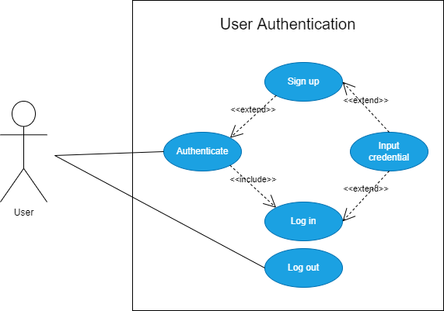

**Figure**: Use case diagram of stakeholder authentication

**Description**

Every single user must pass this authentication step to use this system. If anyone comes to visit this, they can visit the landing pages without any sort of authentication but if anyone wants to use any service of this system, he/she must pass a valid authenticate.

Three types of authentications depending on user-

1. Registration: The new user who do not have any account in this system and want to use some service of this system then he/she should register himself/herself by filling up required credentials and then click register button.
2. Login: The existing user who create an account by registering themselves will authenticate themselves in this section and then click the login button.
3. Log out: The logged in user can logged themselves out whenever they need to do it.
   * 1. Use Case: Company Section

**Diagram:**

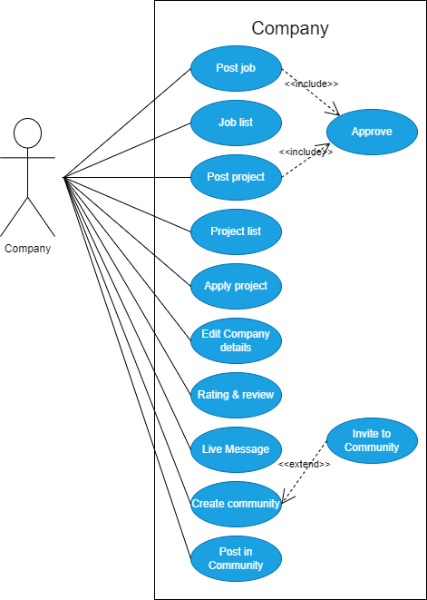

**Figure**: Use case diagram for Company

**Description**

A company profile can do multiple tasks like

1. A company can post a job or project
2. It can approve the appropriate applicant among all of the applications.
3. They can view their posted job or project list.
4. Even a company can apply for another project also.
5. They can review and rate other company, project manager or other applicant for their work.
6. Through this integrated live message system company can communicate anyone, joined this system, related to its work.
7. A company can create a community to discuss on a topic with other members who are in this community.
8. A company can send invitation link to others to join at specific community.
9. Obviously, it can post to any community where it is presented as member or host.
10. Company can update its details.
    * 1. Use Case: Project Manager Section

**Diagram:**

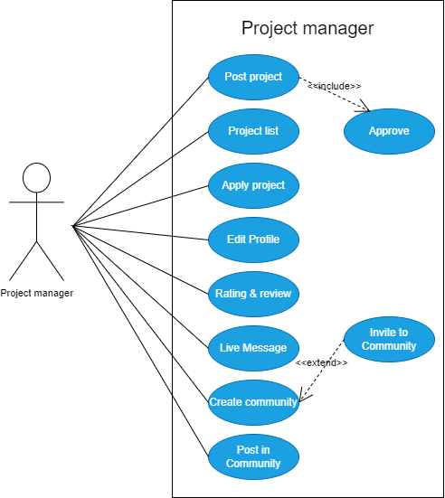

**Figure**: Use case diagram for project manager

**Description**

A project manager can do multiple tasks like

1. He/she can post a project
2. He/she can approve the appropriate applicant among all of the applications.
3. He/she can view his/her posted project list.
4. Even a project manager can apply for another project also.
5. He/she can review and rate other company, project manager or other applicant for their work.
6. Through this integrated live message system, a project manager can communicate anyone, joined this system, related to work.
7. A project manager can create a community to discuss on a topic with other members who are in this community.
8. A project manager can send invitation link to others to join at specific community.
9. Obviously, he/she can post to any community where he/she is presented as member or host.
10. He/she can update his/her profile.
    * 1. Use Case: Applicant Section

**Diagram:**

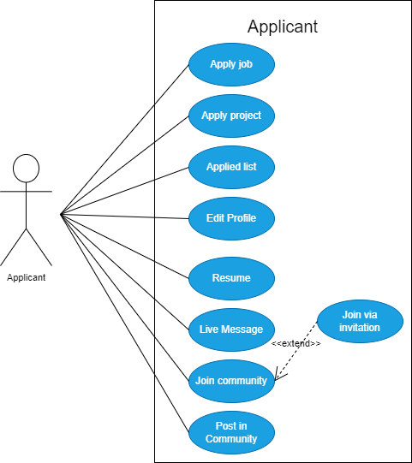

**Figure**: Use case diagram for applicant

**Description**

An applicant has several options to choose like-

1. He/she can apply for a job or a project
2. He/she can view a circular list where he/she applied with each work status.
3. He/she can create a digital resume with all fields needed to make himself/herself perfect to be hired by other companies or project manager.
4. Through this integrated live message system, applicant can communicate anyone, joined this system, related to work.
5. An applicant can join a community to discuss on a topic with other members who are in this community by receiving an invitation link or with join request.
6. He/she can post to any community where he/she is presented as member.
7. He/she can update his/her profile.
   * 1. Use Case: Admin Section

**Diagram:**

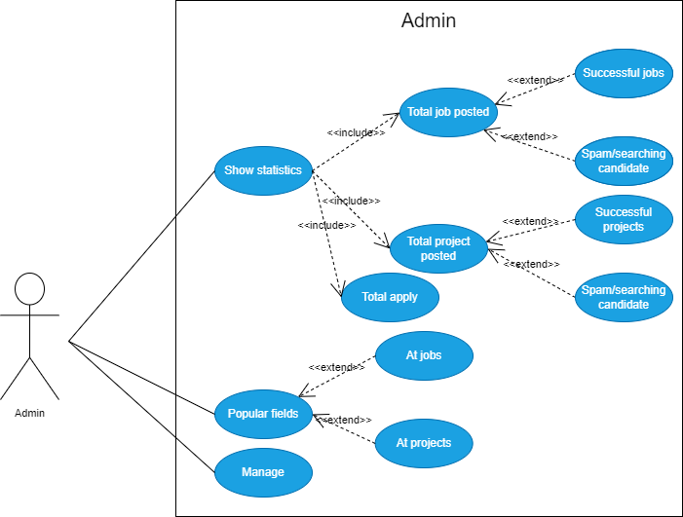

**Figure**: Use case diagram for admin

**Description**

An applicant has several options to choose like-

1. Check statistics to observe the system.
   1. Total job posted
      1. Successful jobs
      2. Jobs that still searching candidate
   2. Total project posted
      1. Successful projects
      2. projects that still searching candidate
   3. Total applies
2. Popular field
   1. At jobs
   2. At projects
3. Manage
   * 1. Use Case: Admin manage Section

**Diagram:**

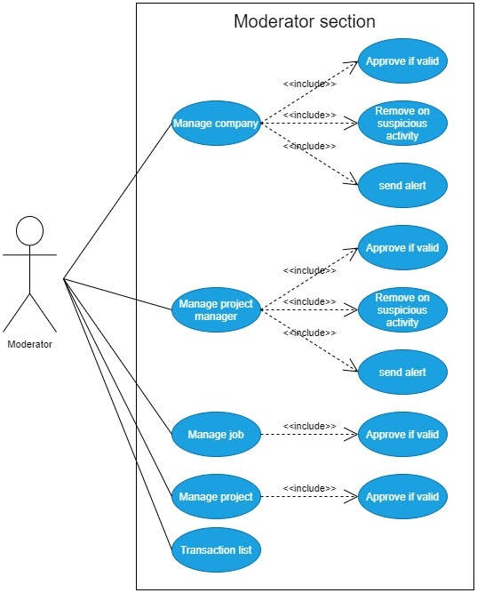

**Figure**: Use case diagram for admin-manage section

**Description**

An applicant has several options to choose like-

1. Manage company
   1. Approve if all info and documents are valid
   2. Ban on suspicious activities
   3. Send any emergency alert
2. Manage project manager
   1. Approve if all info and documents are valid
   2. Ban on suspicious activities
   3. Send any emergency alert
3. Manage job
   1. Approve if job is valid and not suspicious
4. Manage project
   1. Approve if project is valid
5. View Transaction list
   1. Send report on suspicious transaction
   2. Check report feedback from related account
6. Manage applicant account
   1. Non-verified applicant
   2. Manage document for verify

# Use Case Flow, Stakeholder, Conditions

## Authentication

|  |  |
| --- | --- |
| Overview | |
| Use case | Authentication |
| Description | Authenticate real user of this system by considering given credentials |
| Actors | All stakeholder like admin, company, project manager, employee |
| Initial status and pre-condition | 1. Stable internet connection 2. Must be on login or sign-up page and should be at unauthenticated state |
| Basic Flow | STEP-1: Visit Landing page  STEP-2: Click on login if have an account otherwise, click on sign up  STEP-3: Input all credentials correctly  STEP-4: click on login or signup button |
| Post condition | Logged you in the system as a valid user and will be shown a landing page from where one can visit each page as he/she need |

## Logout

|  |  |
| --- | --- |
| Overview | |
| Use case | Authentication |
| Description | Logged out an authenticated user |
| Actors | All stakeholder like admin, company, project manager, employee |
| Initial status and pre-condition | 1. Stable internet connection 2. Stakeholders must be logged in the system |
| Basic Flow | STEP-1: Click on logout |
| Post condition | Logged out an authenticated user from the system |

## Company profile

|  |  |
| --- | --- |
| Overview | |
| Use case | Company section |
| Description | Company details information show |
| Actors | All stakeholder like admin, company, project manager, employee |
| Initial status and pre-condition | 1. Stable internet connection |
| Basic Flow | STEP-1: Click on company name |
| Post condition | Selected company details will be shown on a page |

## Company profile edit

|  |  |
| --- | --- |
| Overview | |
| Use case | Company section |
| Description | Company details information update |
| Actors | Company |
| Initial status and pre-condition | 1. Stable internet connection 2. Must be logged in as a company |
| Basic Flow | STEP-1: Click on update info  STEP-2: Update desired info  STEP-3: Click on update button |
| Post condition | Updated info of the company will be shown on a page |

## Project manager profile

|  |  |
| --- | --- |
| Overview | |
| ID | SRS - 05 |
| Description | Project manager details information show |
| Actors | All stakeholder like admin, company, project manager, employee |
| Initial status and pre-condition | 1. Stable internet connection |
| Basic Flow | STEP-1: Click on project manager name |
| Post condition | Selected project manager details will be shown on a page |

## Project manager profile edit

|  |  |
| --- | --- |
| Overview | |
| Use case | Project manager section |
| Description | Project manager details information update |
| Actors | Project manger |
| Initial status and pre-condition | * 1. Stable internet connection   2. Must be logged in as a project manager |
| Basic Flow | STEP-1: Click on update info  STEP-2: Update desired info  STEP-3: Click on update button |
| Post condition | Updated info of the project manager will be shown on a page |

## Employee profile

|  |  |
| --- | --- |
| Overview | |
| Use case | Employee section |
| Description | Employee details information show |
| Actors | All stakeholder like admin, company, project manager, employee |
| Initial status and pre-condition | 1. Stable internet connection |
| Basic Flow | STEP-1: Click on employee name |
| Post condition | Selected employee details will be shown on a page |

## Employee profile edit

|  |  |
| --- | --- |
| Overview | |
| Use case | Employee section |
| Description | Employee details information update |
| Actors | Employee |
| Initial status and pre-condition | * 1. Stable internet connection   2. Must be logged in as a employee |
| Basic Flow | STEP-1: Click on update info  STEP-2: Update desired info  STEP-3: Click on update button |
| Post condition | Updated info of the employee will be shown on a page |

## Job list

|  |  |
| --- | --- |
| Overview | |
| Use case | Employee, admin section |
| Description | All jobs which will take candidate will be shown as list |
| Actors | Employee, company, admin |
| Initial status and pre-condition | * 1. Stable internet connection   2. Must be logged in as an employee, company, admin   3. Click on available jobs |
| Basic Flow | STEP-1: Scroll down to see one’s desired job |
| Post condition | All apply able jobs will be presented to actors as listed |

## Project list

|  |  |
| --- | --- |
| Overview | |
| Use case | Company, project manager, Employee, admin section |
| Description | All Projects which will take candidate will be shown as list |
| Actors | Admin, company, project manager and employee |
| Initial status and pre-condition | * 1. Stable internet connection   2. Must be logged in as an employee, admin, company, project manager   3. Click on available projects |
| Basic Flow | STEP-1: Scroll down to see one’s desired project |
| Post condition | All apply able projects will be presented to stakeholder as listed |

## Job details

|  |  |
| --- | --- |
| Overview | |
| Use case | Employee, admin section |
| Description | One single job will be shown to stakeholder with its all details like about the job, what is the responsibility, where should employee work at, what about the experience, is the job remote or offline etc. |
| Actors | Employee |
| Initial status and pre-condition | * 1. Stable internet connection   2. Must be logged in as an employee, admin |
| Basic Flow | STEP-1: Click on specific job Requirement title |
| Post condition | With all details the clicked job will be presented to actors |

## Project details

|  |  |
| --- | --- |
| Overview | |
| Use case | Employee, project manager, company, admin section |
| Description | One single project will be shown to actors with its all details like what about the project, what should employee do, before when employee should submit it and so on |
| Actors | Admin, company, project manager and employee |
| Initial status and pre-condition | * 1. Stable internet connection   2. Must be logged in as an employee or project manager or company or admin |
| Basic Flow | STEP-1: Click on specific project Requirement title |
| Post condition | With all details the clicked project will be presented to actors |

## Featured Job list

|  |  |
| --- | --- |
| Overview | |
| Use case | Company section |
| Description | Show all jobs by listed which posted by logged in company |
| Actors | Company |
| Initial status and pre-condition | * 1. Stable internet connection   2. Must be logged in as a company |
| Basic Flow | STEP-1: Click on featured jobs |
| Post condition | All jobs which posted by logged in company will be presented to stakeholder as listed |

## Featured Project list

|  |  |
| --- | --- |
| Overview | |
| Use case | Company, project manager section |
| Description | Show all jobs by listed which posted by logged in company or project manager |
| Actors | Company, project manager |
| Initial status and pre-condition | * 1. Stable internet connection   2. Must be logged in as a company or project manager |
| Basic Flow | STEP-1: Click on featured projects |
| Post condition | All projects which posted by logged in company or project manager will be presented to stakeholder as listed |

## Job applies

|  |  |
| --- | --- |
| Overview | |
| Use case | Employee section |
| Description | Show all required fields for filling up to apply a job |
| Actors | Employee |
| Initial status and pre-condition | * 1. Stable internet connection   2. Must be logged in as an employee |
| Basic Flow | STEP-1: Click on apply button from a job detail  STEP-2: Fill all the requirements to apply and click apply |
| Post condition | A redirected page will be shown with all detail of apply and with the status of the result of appointment |

## Project applies

|  |  |
| --- | --- |
| Overview | |
| Use case | Company, project manager, employee section |
| Description | Show all required fields for filling up to apply a job |
| Actors | Company, project manager, employee |
| Initial status and pre-condition | * 1. Stable internet connection   2. Must be logged in as a company or project manager or an employee |
| Basic Flow | STEP-1: Click on apply button from a project detail  STEP-2: Fill all the requirements to apply and click apply |
| Post condition | A redirected page will be shown with all detail of apply and with the status |

## Employee resume

|  |  |
| --- | --- |
| Overview | |
| Use case | Employee section |
| Description | Show all necessary field to complete one’s resume |
| Actors | Employee |
| Initial status and pre-condition | * 1. Stable internet connection   2. Must be logged in as an employee |
| Basic Flow | STEP-1: Click on resume section  STEP-2: Fill all the requirements to create an appropriate resume |
| Post condition | A refreshed page will be shown with all information |

## Company info

|  |  |
| --- | --- |
| Overview | |
| Use case | Company section |
| Description | Show all necessary field to complete company’s info |
| Actors | Company |
| Initial status and pre-condition | * 1. Stable internet connection   2. Must be logged in as a company |
| Basic Flow | STEP-1: Click on company info  STEP-2: Fill all the requirements to become a proper company |
| Post condition | A refreshed page will be shown with all information |

## Project manager detail

|  |  |
| --- | --- |
| Overview | |
| Use case | Project manager section |
| Description | Show all necessary field to complete manager detail |
| Actors | Project manager |
| Initial status and pre-condition | * 1. Stable internet connection   2. Must be logged in as a project manger |
| Basic Flow | STEP-1: Click on project manager detail section  STEP-2: Fill all the requirements to become a proper project manager to get projects from market place |
| Post condition | A refreshed page will be shown with all information |

## Community

|  |  |
| --- | --- |
| Overview | |
| Use case | Company, project manager, employee section |
| Description | Community details with all activities |
| Actors | Company, project manager and employee |
| Initial status and pre-condition | * 1. Stable internet connection   2. Must be logged in as a company or project manager or an employee |
| Basic Flow | STEP-1: Click on community section |
| Post condition | All community will be shown as a list with small details about the community |

## Create community

|  |  |
| --- | --- |
| Overview | |
| Use case | Company, project manager, employee section |
| Description | Create new community to add new discussion with people |
| Actors | Premium Company, project manager, employee |
| Initial status and pre-condition | * 1. Stable internet connection   2. Must be logged in as a premium company or project manager or an employee |
| Basic Flow | STEP-1: Click on create community  STEP-2: Fill up all the required fields to create a community  STEP-3: Click on the create button |
| Post condition | New community with proper details and also with an invitation link will be shown up to user |

* + 1. Post in community

|  |  |
| --- | --- |
| Overview | |
| Use case | Company, project manager, employee section |
| Description | Post anything related to specific community |
| Actors | Premium company, project manager and employee |
| Initial status and pre-condition | * 1. Stable internet connection   2. Must be logged in as a premium company or project manager or an employee |
| Basic Flow | STEP-1: Click on create new post  STEP-2: Fill up all the required fields to post something  STEP-3: Click on the post now button |
| Post condition | All post of that community will be shown as a list with details |

## Live message

|  |  |
| --- | --- |
| Overview | |
| Use case | Company, project manager, employee section |
| Description | Discuss about project or job related any topic via this live message system so that company or project manager or even the employee need not to take any help from other third party help to talk with each other |
| Actors | Company, project manager and employee |
| Initial status and pre-condition | * 1. Stable internet connection   2. Must be logged in as a company or project manager or an employee |
| Basic Flow | STEP-1: Click on chat  STEP-2: Type message and attach any attachment if needed  STEP-3: Click on the send button |
| Post condition | Chat of both people will be displayed nicely |

## FAQ

|  |  |
| --- | --- |
| Overview | |
| Use case | Company, project manager, employee section |
| Description | This is all about frequently asked common question by any user from their aspect |
| Actors | Company, project manager, employee and any guest user |
| Initial status and pre-condition | * 1. Stable internet connection   2. Must be logged in as a company or project manager or an employee |
| Basic Flow | STEP-1: Click on FAQ section to the question and answer |
| Post condition | Answer with each relevant question will be shown |

## Notification

|  |  |
| --- | --- |
| Overview | |
| Use case | Company, project manager, employee section |
| Description | Notification on different activities like accepting new project, job or even any sort of notification from admin also |
| Actors | Company, project manager and employee |
| Initial status and pre-condition | * 1. Stable internet connection   2. Must be logged in as a company or project manager or an employee |
| Basic Flow | STEP-1: Click on notification icon |
| Post condition | View all sort of notification and can click on one to see any details about that issue |

## Applied list

|  |  |
| --- | --- |
| Overview | |
| Use case | admin section |
| Description | All applied list of employees who applied for job, project and also the applied list of company and project manager who applied for project |
| Actors | admin |
| Initial status and pre-condition | * 1. Stable internet connection   2. Must be logged in as an admin |
| Basic Flow | STEP-1: Click on view applied list option |
| Post condition | View list of employees, company and project manager who applied for a job or project |

## Apply detail

|  |  |
| --- | --- |
| Overview | |
| Use case | admin section |
| Description | Detail of specific applied job or project and applied actor |
| Actors | admin |
| Initial status and pre-condition | * 1. Stable internet connection   2. Must be logged in as an admin |
| Basic Flow | STEP-1: Click on details button at the end of the row of the list |
| Post condition | Detail data of specific applied job or project and applied actor |

## Popular fields

|  |  |
| --- | --- |
| Overview | |
| Use case | admin section |
| Description | Detail of popular field on job and project |
| Actors | admin |
| Initial status and pre-condition | * 1. Stable internet connection   2. Must be logged in as an admin |
| Basic Flow | STEP-1: Click on popular fields to see where people are interested for jobs and also at projects |
| Post condition | Show fields name depending on jobs and projects |

## Approve company, project manager & employee

|  |  |
| --- | --- |
| Overview | |
| Use case | admin section |
| Description | Approve company, project manager and employee depending on their proper id prove |
| Actors | admin |
| Initial status and pre-condition | * 1. Stable internet connection   2. Must be logged in as an admin |
| Basic Flow | STEP-1: Click on manage to approve each newly registered company, project manager and employee depending on their given ID prove |
| Post condition | Status will be changed to verified for company, project manager or employee |

## Report

|  |  |
| --- | --- |
| Overview | |
| Use case | admin section |
| Description | Send a report notification to a company or project manager or employee for any transaction or activities if it seems suspicious to admin |
| Actors | admin |
| Initial status and pre-condition | * 1. Stable internet connection   2. Must be logged in as an admin |
| Basic Flow | STEP-1: Click on manage to report a company, project manager and employee on their activities and transactions |
| Post condition | Redirect to report list to check defending reply from specific actor about that activity for which he/she got a report |

## Ban company, project manager & employee

|  |  |
| --- | --- |
| Overview | |
| Use case | admin section |
| Description | Ban company, project manager and employee depending on their suspicious activities or disobeying term & condition |
| Actors | admin |
| Initial status and pre-condition | * 1. Stable internet connection   2. Must be logged in as an admin |
| Basic Flow | STEP-1: Click on manage to ban each company, project manager and employee on their activities that violates terms & conditions |
| Post condition | Ban list of company or project manager or employee will be shown with new banned company or project manager or employee |

## Approve job, project

|  |  |
| --- | --- |
| Overview | |
| Use case | admin section |
| Description | Approve any job or project after checking its validity |
| Actors | Admin |
| Initial status and pre-condition | * 1. Stable internet connection   2. Must be logged in as an admin |
| Basic Flow | STEP-1: Click on manage to approve job or project after finding it valid and anyone will not be cheated who will apply |
| Post condition | Redirect to project or job list after approving otherwise admin will be redirected to rejected job or project list |

## Bookmark

|  |  |
| --- | --- |
| Overview | |
| Description | Bookmark any job or project or any community post to checking it later |
| Actors | Company, project manager and employee |
| Initial status and pre-condition | * 1. Stable internet connection   2. Must be logged in as a company or project manager or an employee |
| Basic Flow | STEP-1: Click on project manager detail section  STEP-2: Click the bookmark icon to list a job or project or any post at your job list |
| Post condition | Item will be added on bookmark list |

## Remote desktop

|  |  |
| --- | --- |
| Overview | |
| Use Case | Remote Desktop |
| Description | Remote desktop facilities to those who are hired for remote job |
| Actors | Company, project manager and employee |
| Initial status and pre-condition | * 1. Stable internet connection   2. Must be logged in as a company or project manager or an employee |
| Basic Flow | STEP-1: Click on remote job to use the computer of company or the project manager’s computer to do the job |
| Post condition | Use another person computer to do one’s job for any emergency or in remote job section |

# Activity Diagram

## Authentication

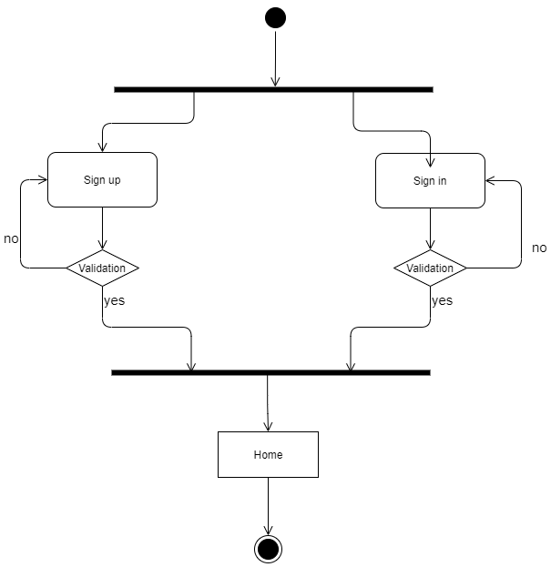

**Figure:** Activity Diagram (Authentication)

## Logout

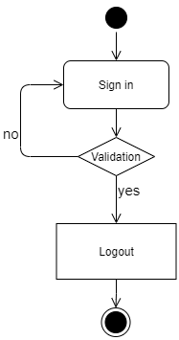

**Figure:** Activity Diagram (Logout)

## Post new job

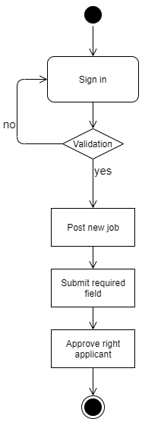

**Figure:** Activity Diagram (post new job)

## Post new project

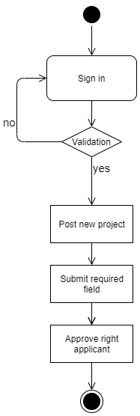

**Figure:** Activity Diagram (post new project)

## Job list

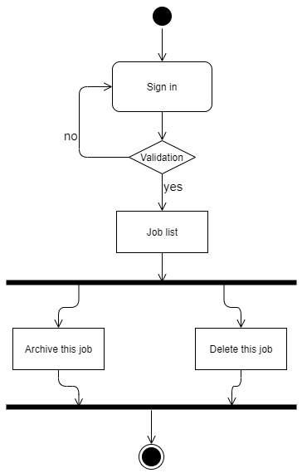

**Figure:** Activity Diagram (Job list)

## Project list

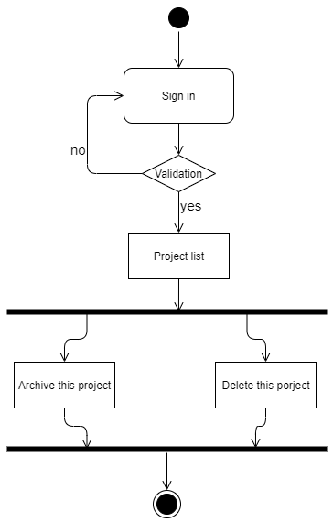

**Figure:** Activity Diagram (project list)

## Apply Job

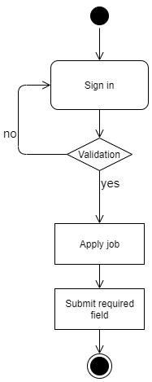

**Figure:** Activity Diagram (apply job)

## Apply Project

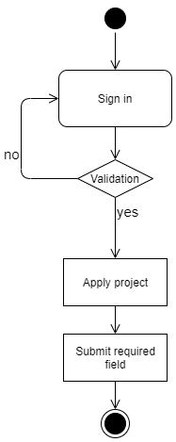

**Figure:** Activity Diagram (apply project)

## Applied list

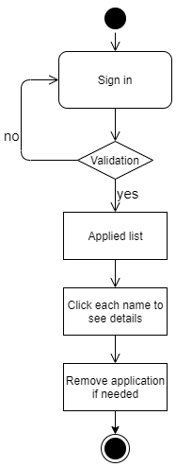

**Figure:** Activity Diagram (applied list)

## Profile section

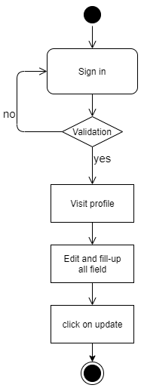

**Figure:** Activity Diagram (profile section)

## Submitting comment

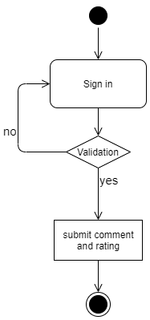

**Figure:** Activity Diagram (commenting)

## Creating and updating resume

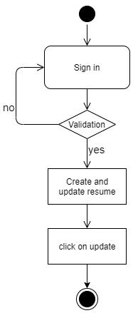

**Figure:** Activity Diagram (create and updating resume)

## Creating community

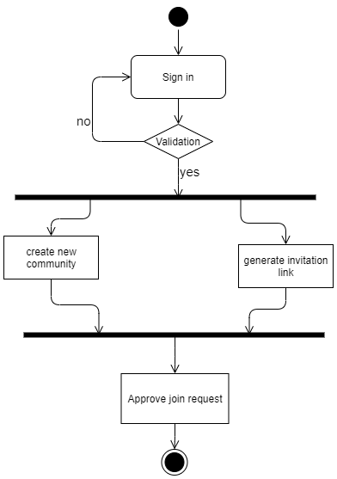

**Figure:** Activity Diagram (community creating)

## Joining Community

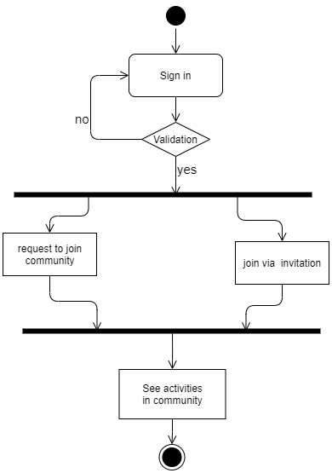

**Figure:** Activity Diagram (joining community)

## Post in community

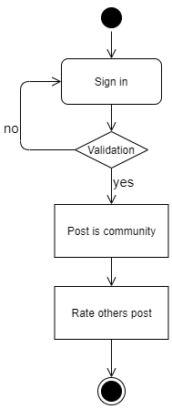

**Figure:** Activity Diagram (post in community)

## Live messaging

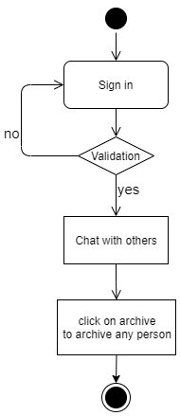

**Figure:** Activity Diagram (live messaging)

## Remote support

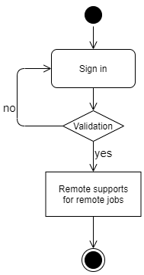

**Figure:** Activity Diagram (remote support)

## Online meeting

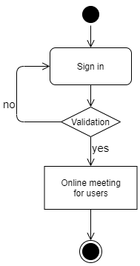

**Figure:** Activity Diagram (online meeting)

## Manage projects, jobs, applied list

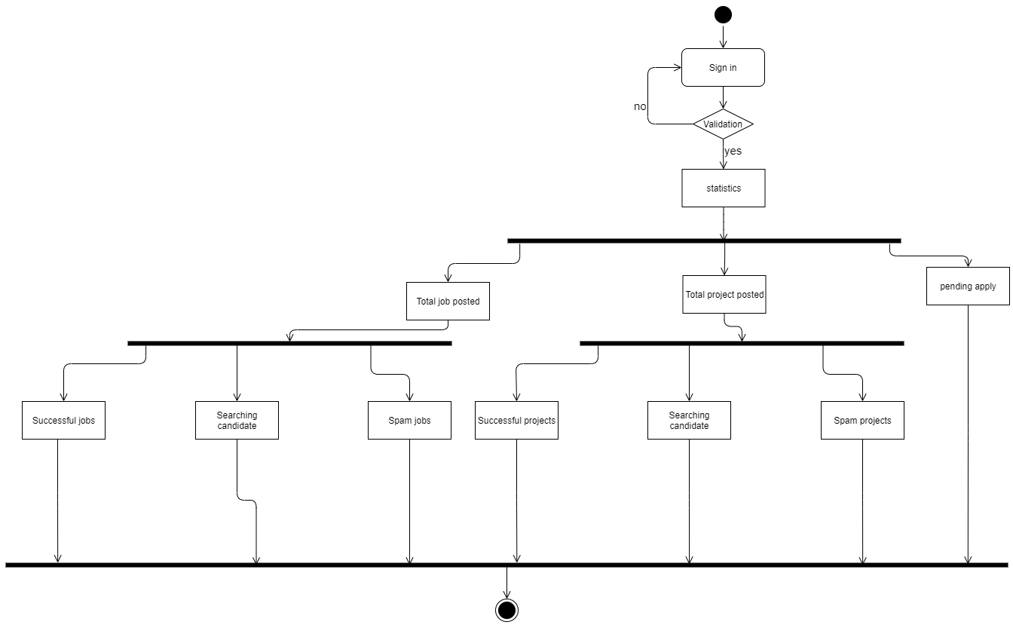

**Figure:** Activity Diagram (Manage projects, jobs, applied list)

## See popular jobs

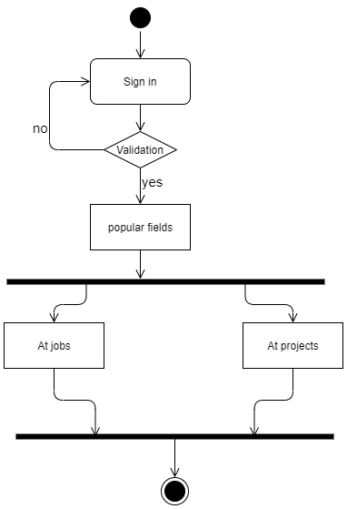

**Figure:** Activity Diagram (popular job)

## Verify company

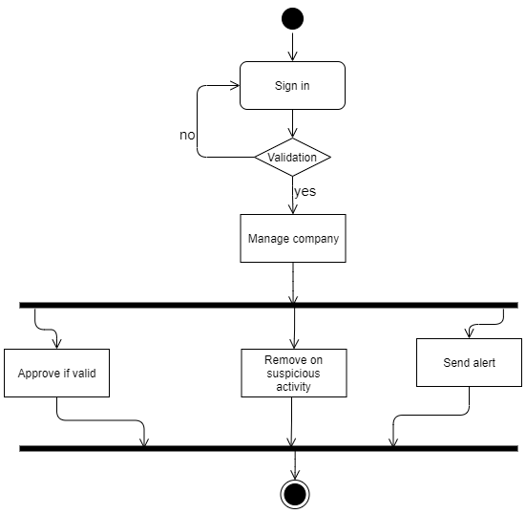

**Figure:** Activity Diagram (verify company)

## Verify Project manager

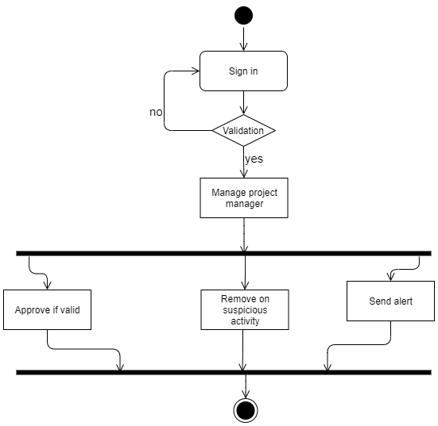

**Figure:** Activity Diagram (verify project manager)

## Verify jobs

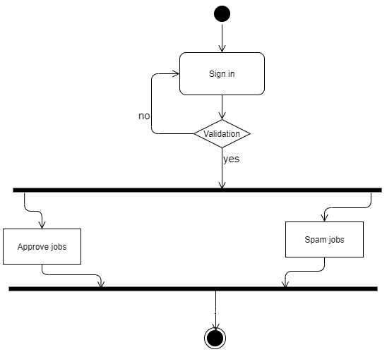

**Figure:** Activity Diagram (verify jobs)

## Verify projects

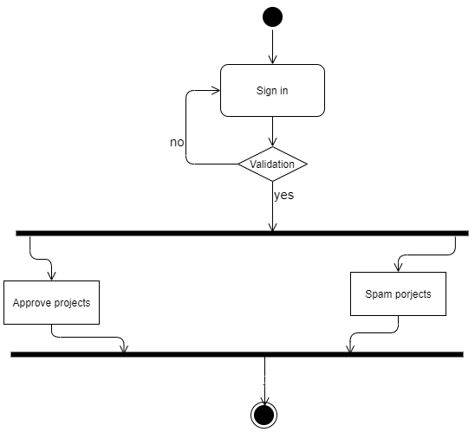

**Figure:** Activity Diagram (verify projects)

# Sequence Diagram

## Sign Up

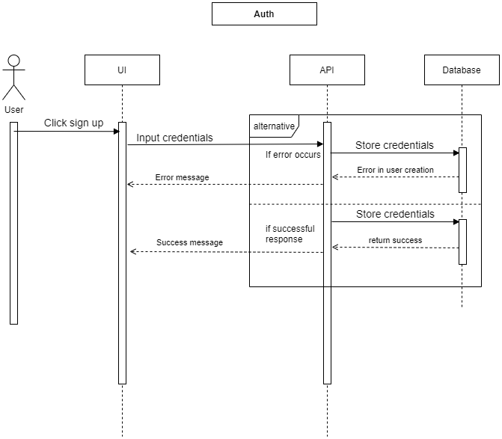

**Figure:** Sequence Diagram (Sign up)

## Sign In

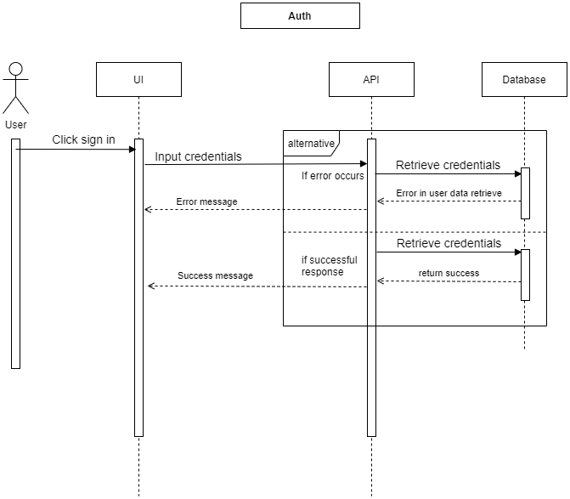  
**Figure:** Sequence Diagram (Sign in)

## Log out

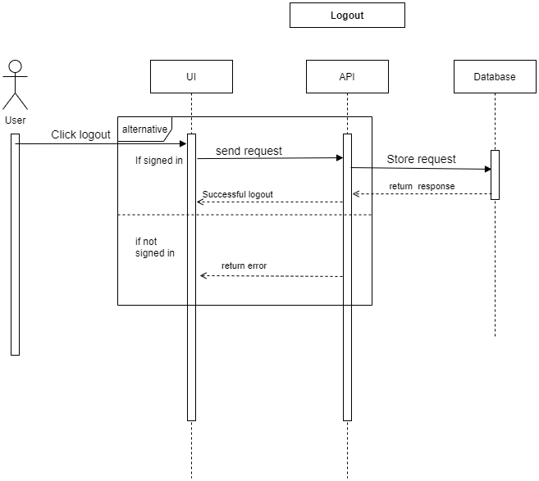

**Figure:** Sequence Diagram (Log out)

## Post a job

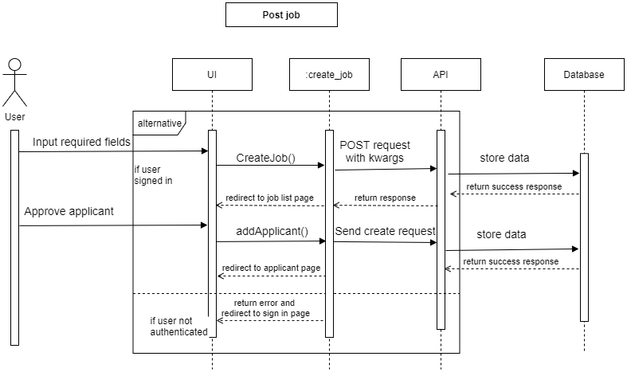  
**Figure:** Sequence Diagram (post job)

## Post a project

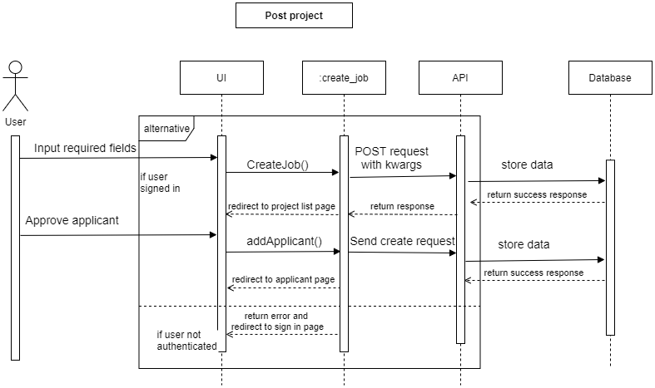

**Figure:** Sequence Diagram (post project)

## Job list

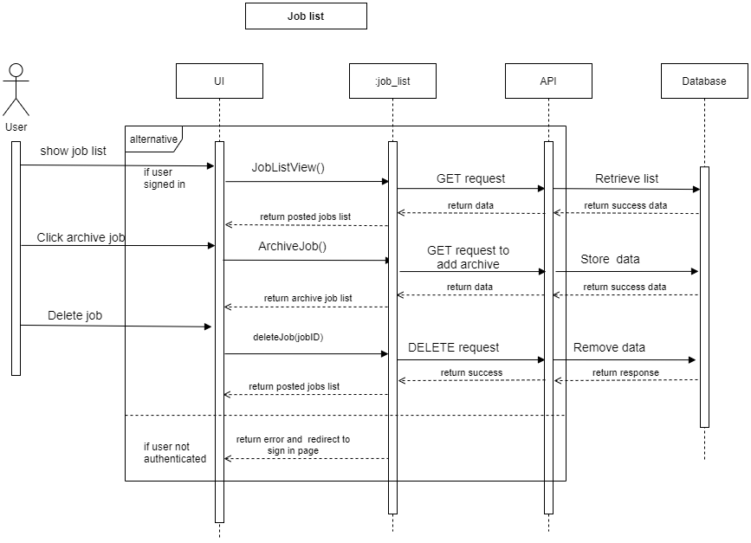

**Figure:** Sequence Diagram (job list)

## Project list

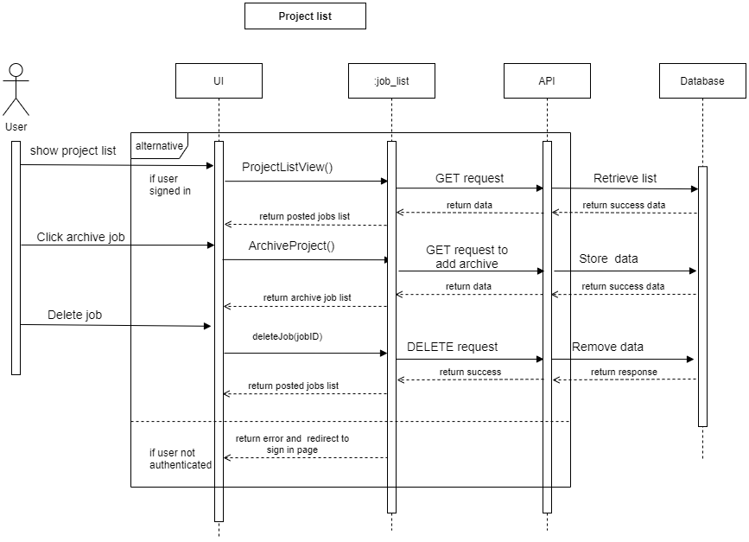

**Figure:** Sequence Diagram (project list)

## Apply job

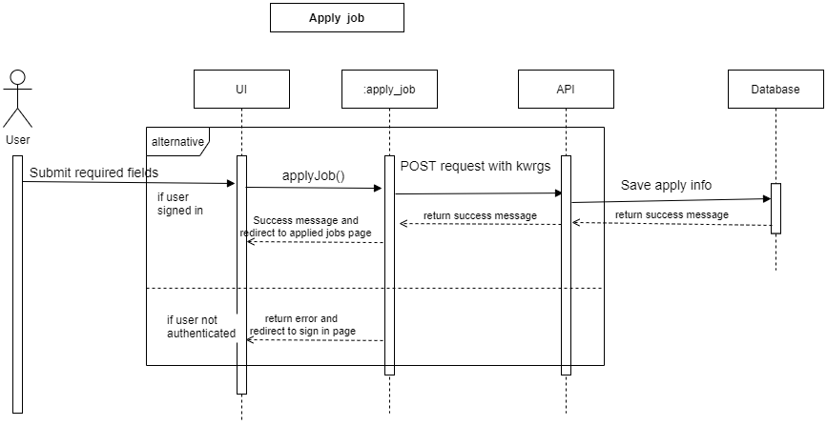

**Figure:** Sequence Diagram (apply job)

## Apply project

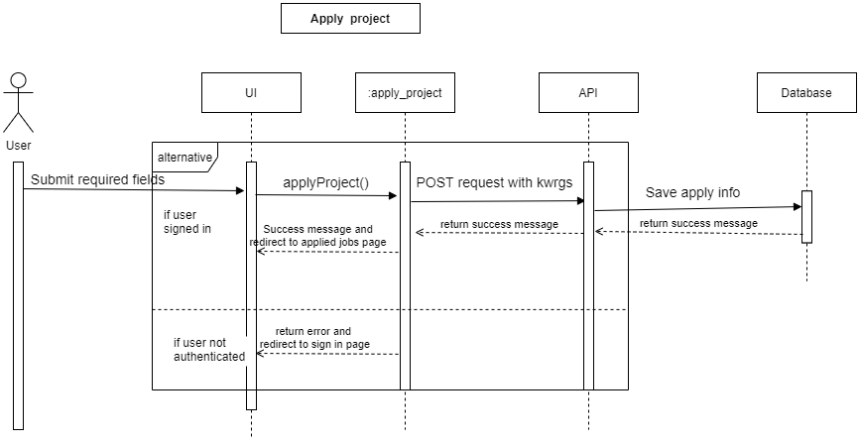

**Figure:** Sequence Diagram (apply project)

## Create new community

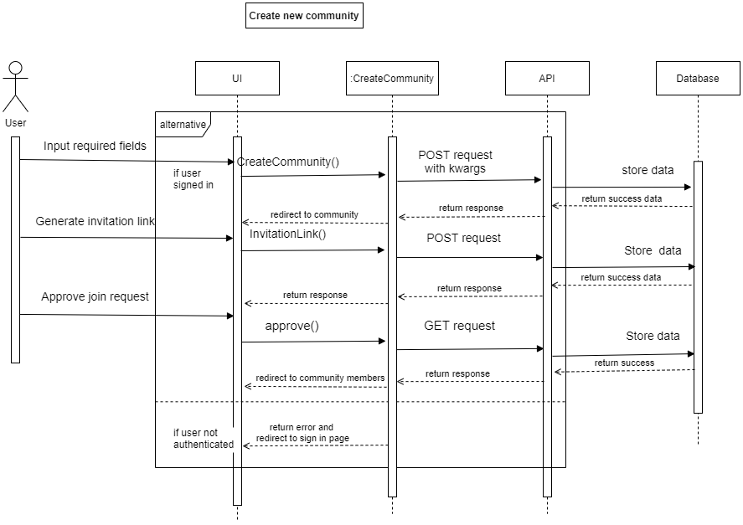

**Figure:** Sequence Diagram (create community)

## Edit details

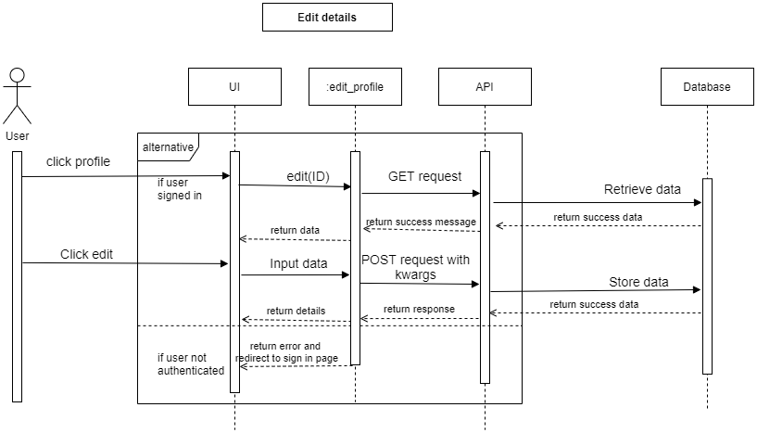

**Figure:** Sequence Diagram (edit details)

## Remote facilities

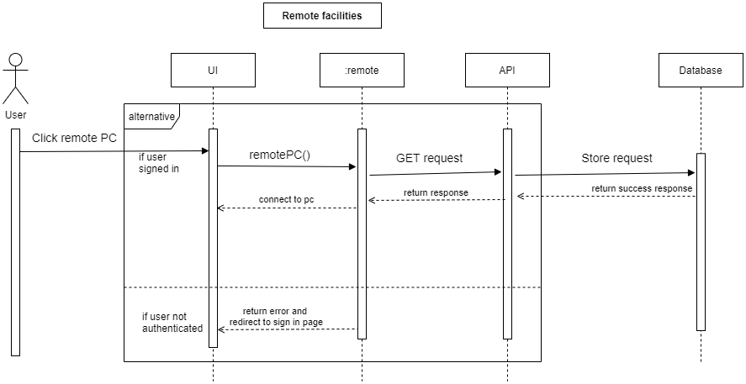

**Figure:** Sequence Diagram (Remote facilities)

## Online meeting

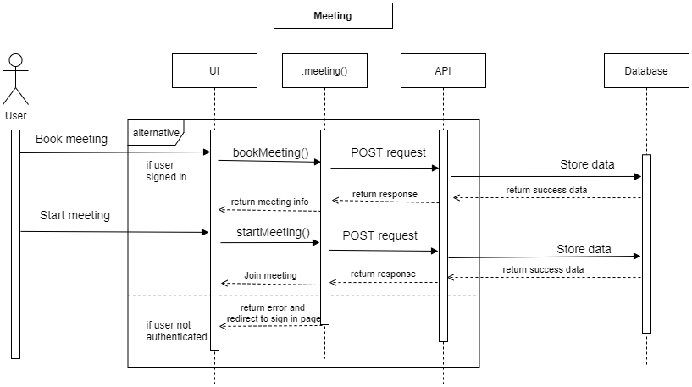

**Figure:** Sequence Diagram (Online Meeting)

## Rating & review

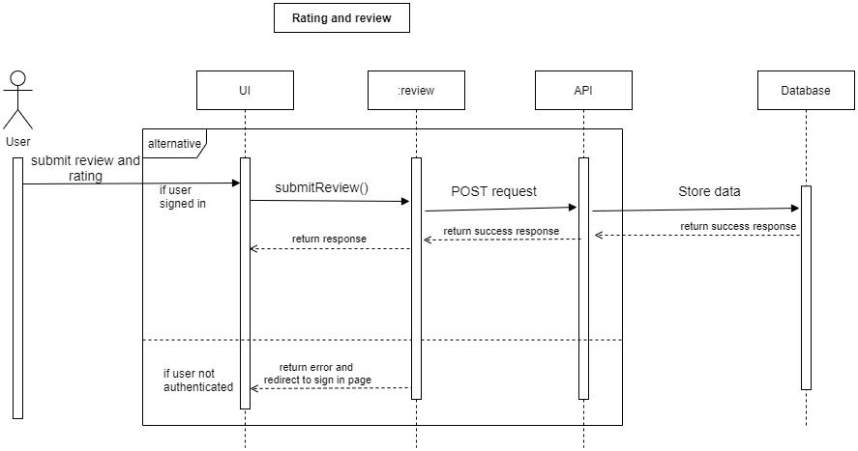

**Figure:** Sequence Diagram (rating and review)

## Applied list

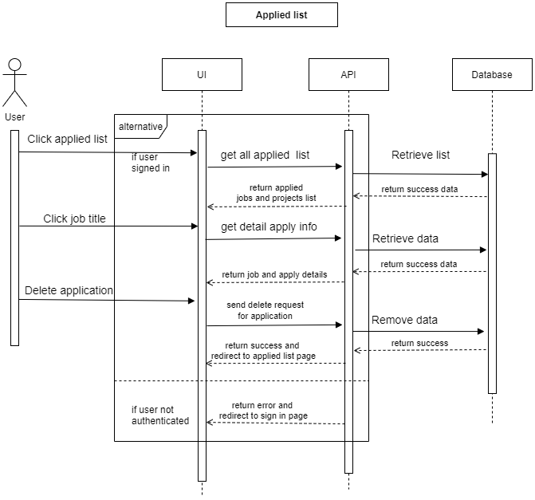

**Figure:** Sequence Diagram (applied list)

## Join community

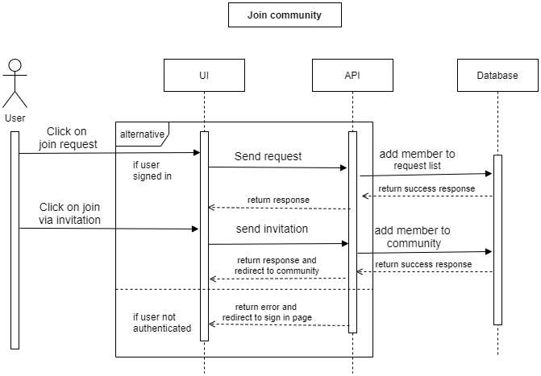

**Figure:** Sequence Diagram (join community)

## Post in community

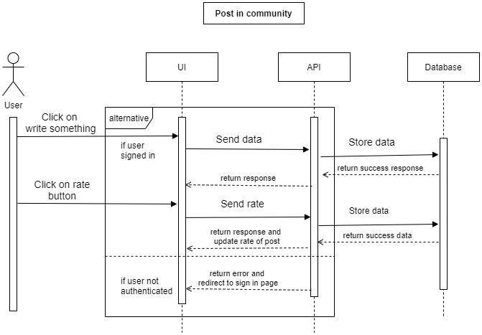

**Figure:** Sequence Diagram (post in community)

## Resume

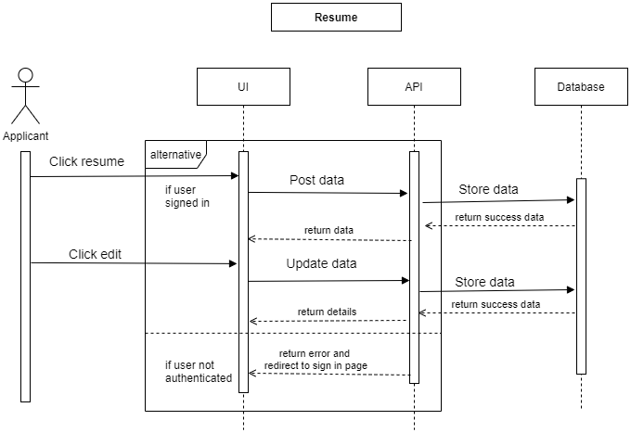

**Figure:** Sequence Diagram (Resume)

## Manage Company

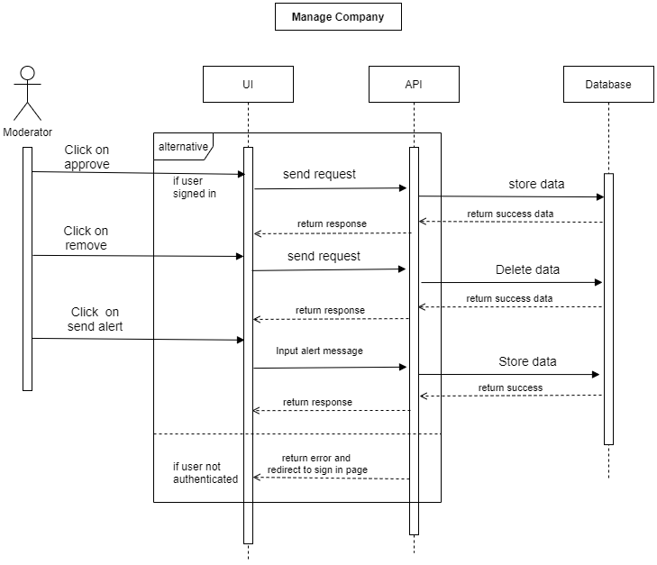

**Figure:** Sequence Diagram (Manage company)

## Manage project manager

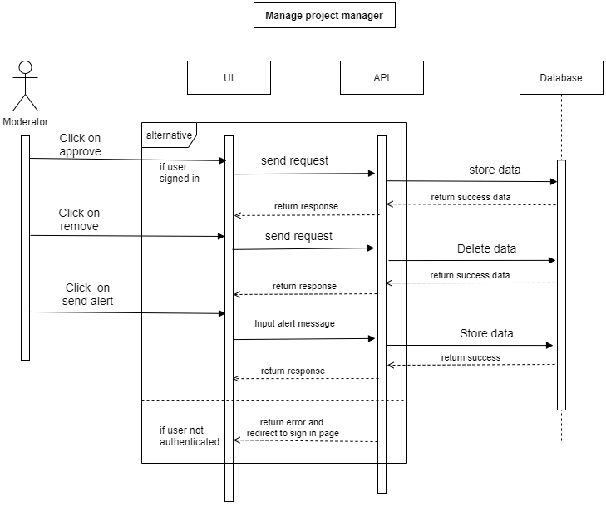

**Figure:** Sequence Diagram (manage project manager)

## Manage job

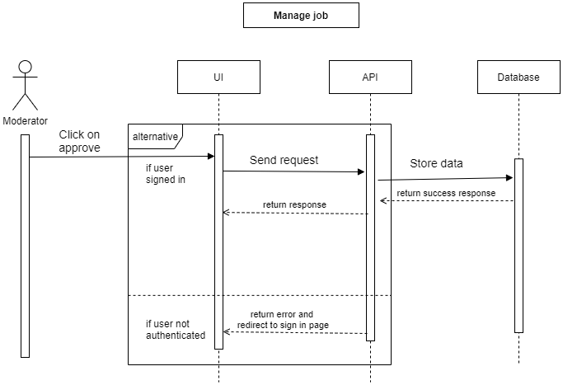

**Figure:** Sequence Diagram (manage job)

## Manage project

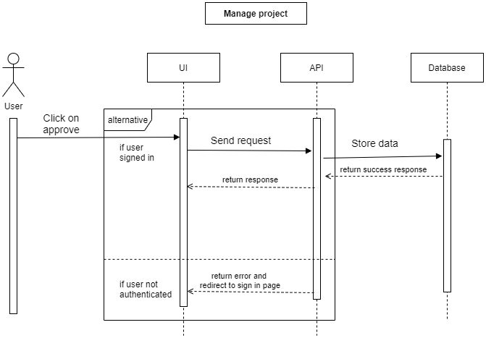

**Figure:** Sequence Diagram (manage project)

## Statistics

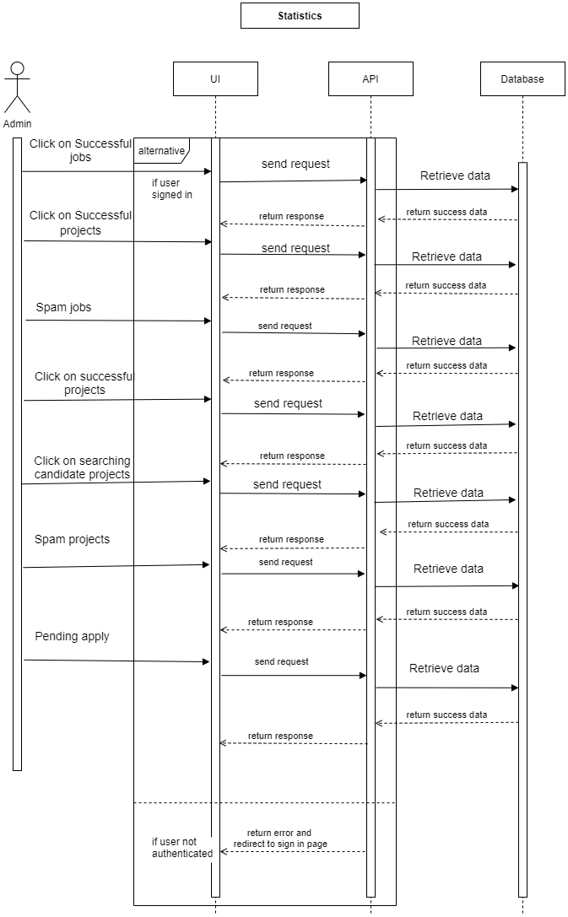

**Figure:** Sequence Diagram (statistics)

## Popular fields

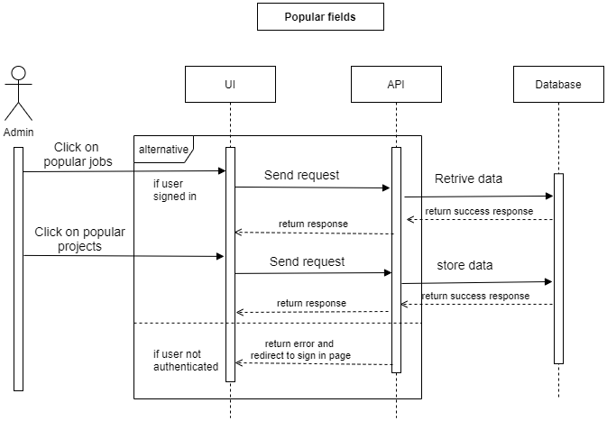

**Figure:** Sequence Diagram (popular fields)

## Transaction list

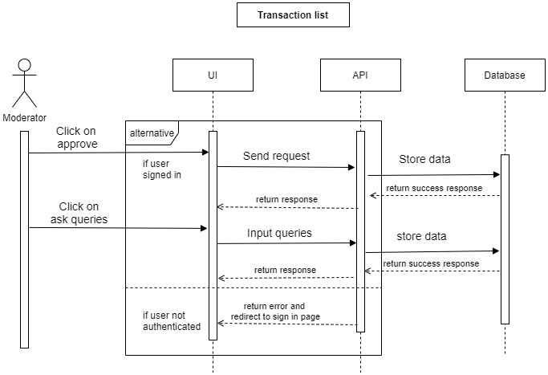

**Figure:** Sequence Diagram (transaction list)

## Resume



**Figure:** Sequence Diagram (resume)

# Entity Relationship Diagram

# Full diagram

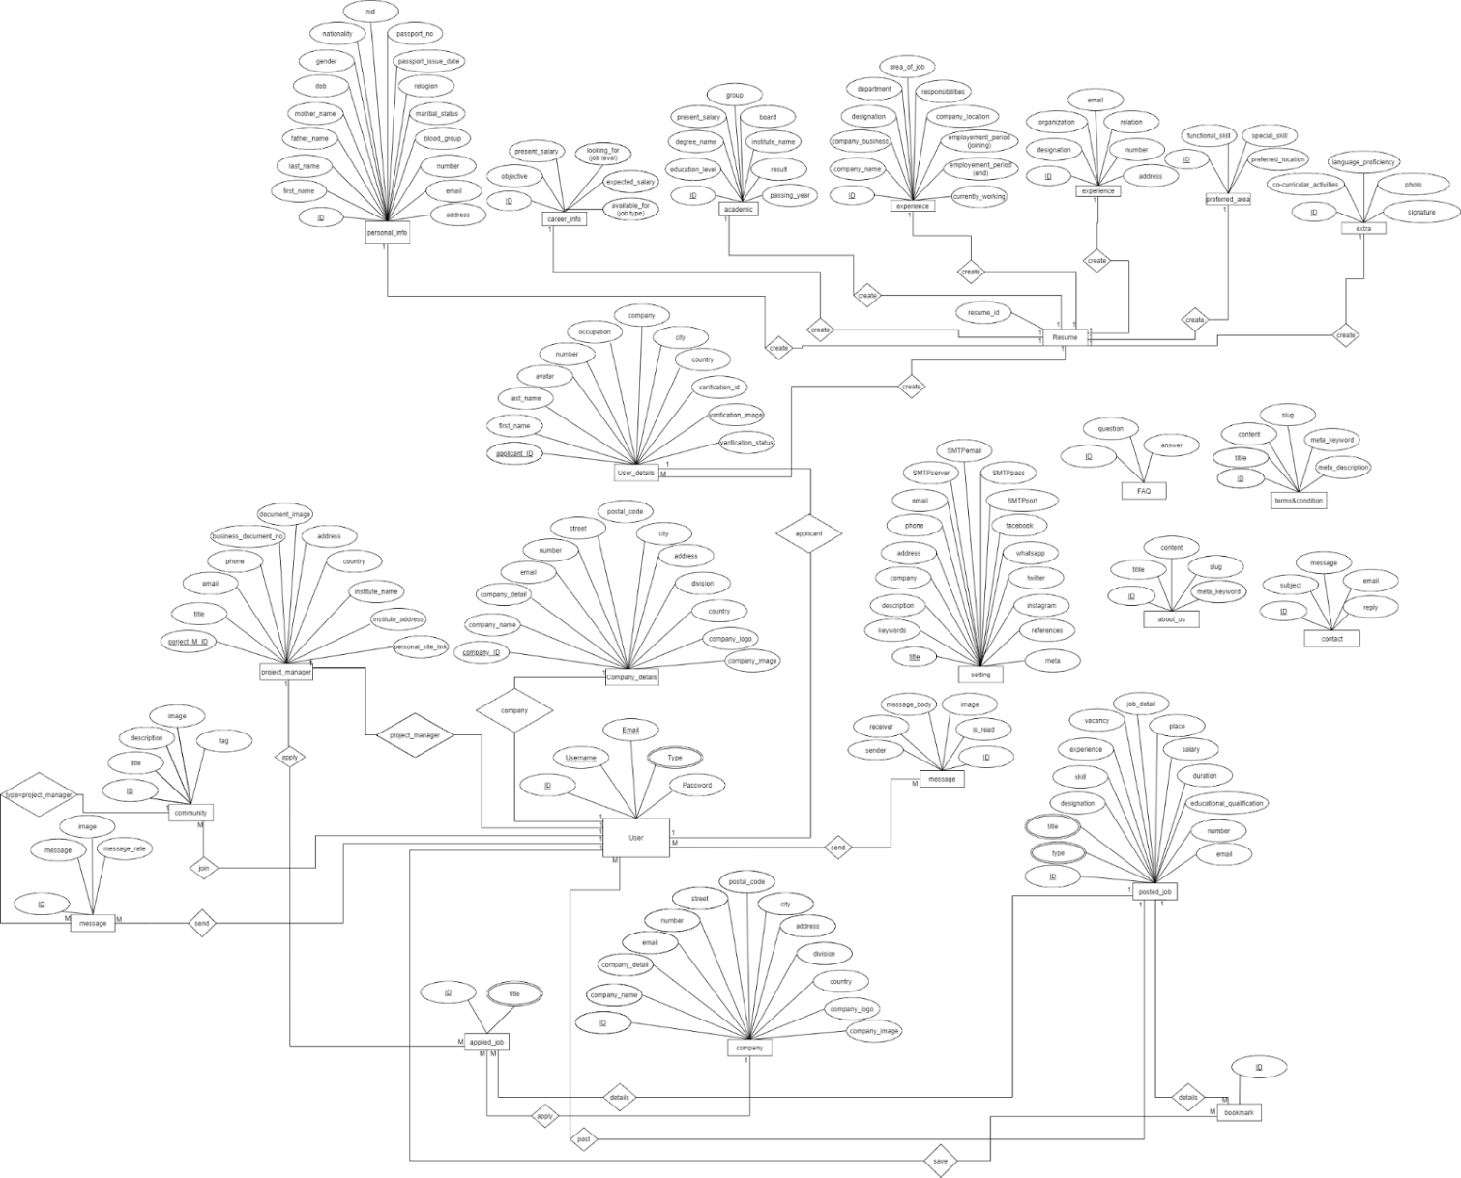

**Figure:** Entity Relationship Diagram

## Normalize ER Diagram

## Part-1

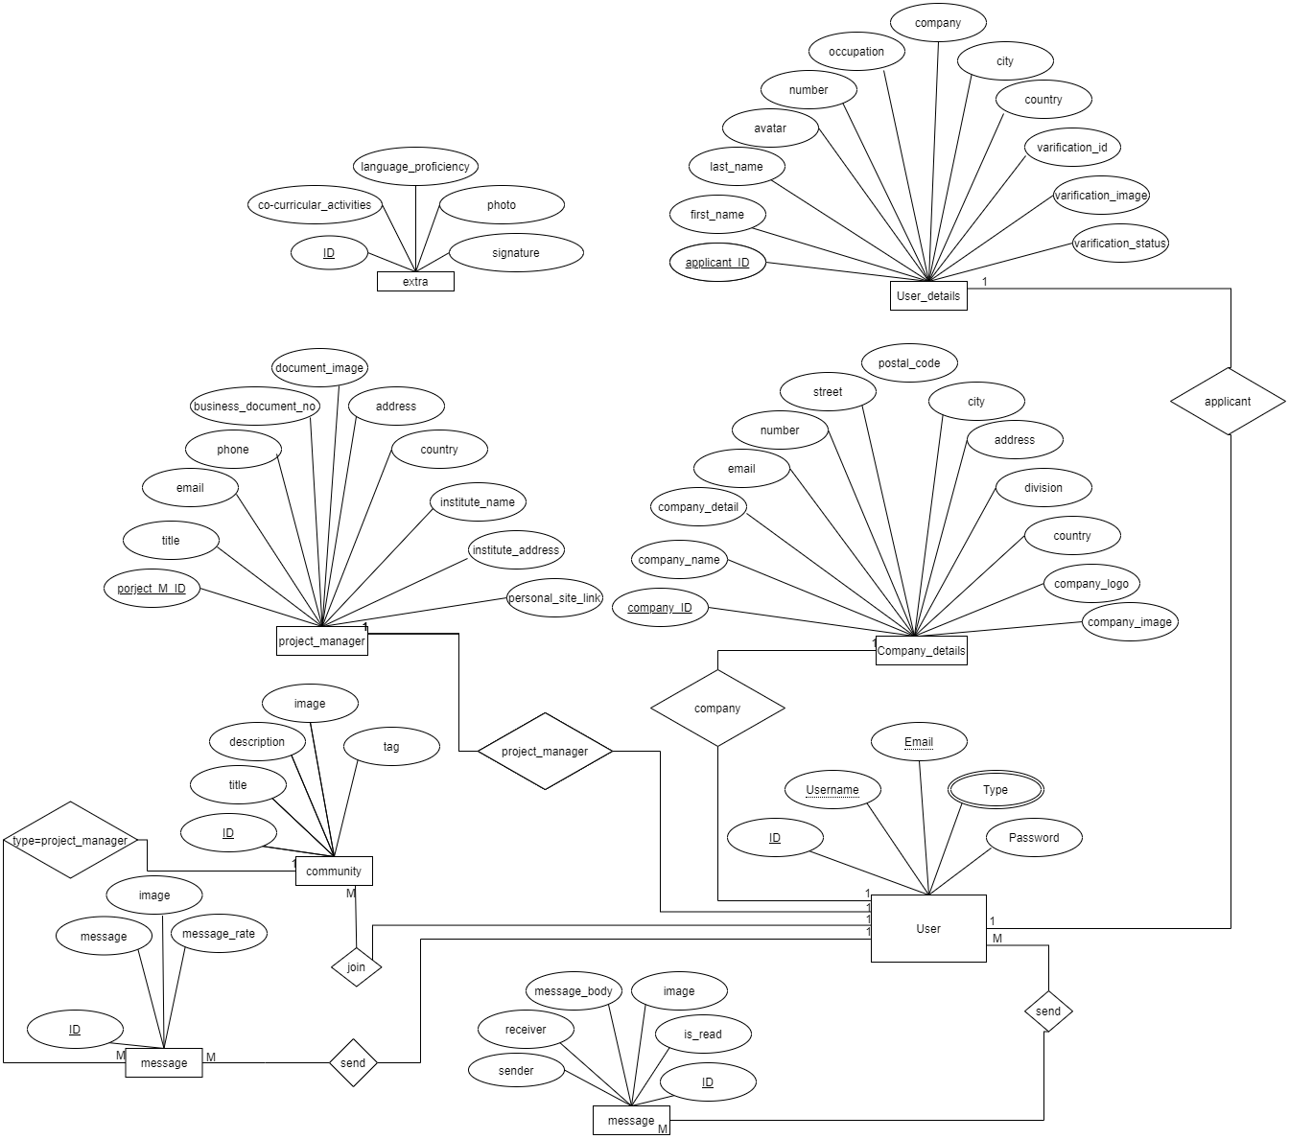

**Figure:** Entity Relationship Diagram(part-1)

### Part-2

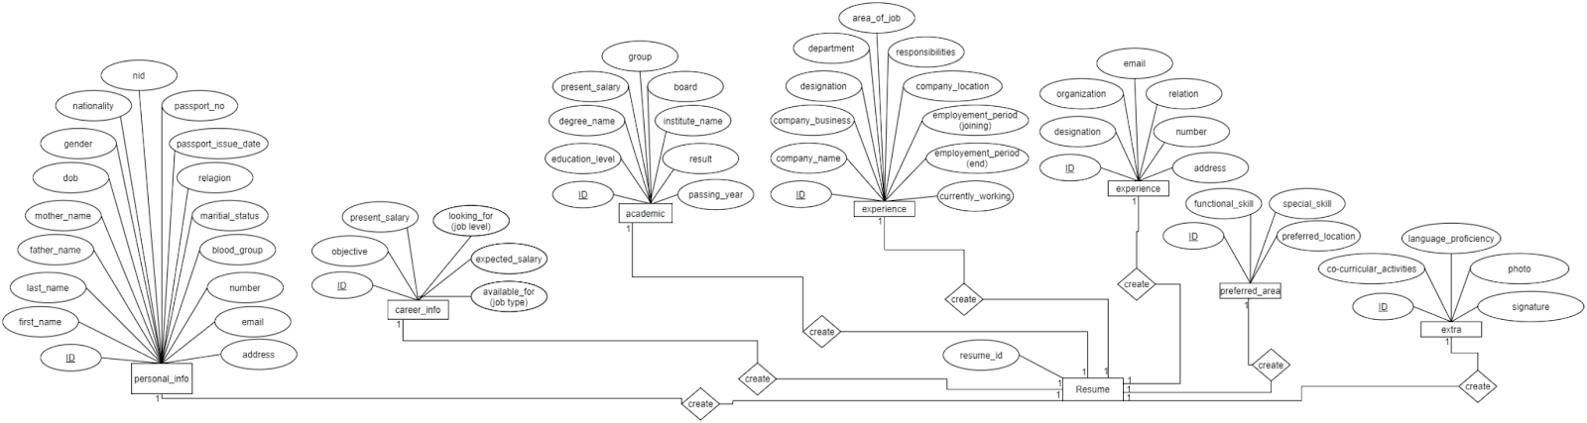

**Figure:** Entity Relationship Diagram(part-2)

### Part-3

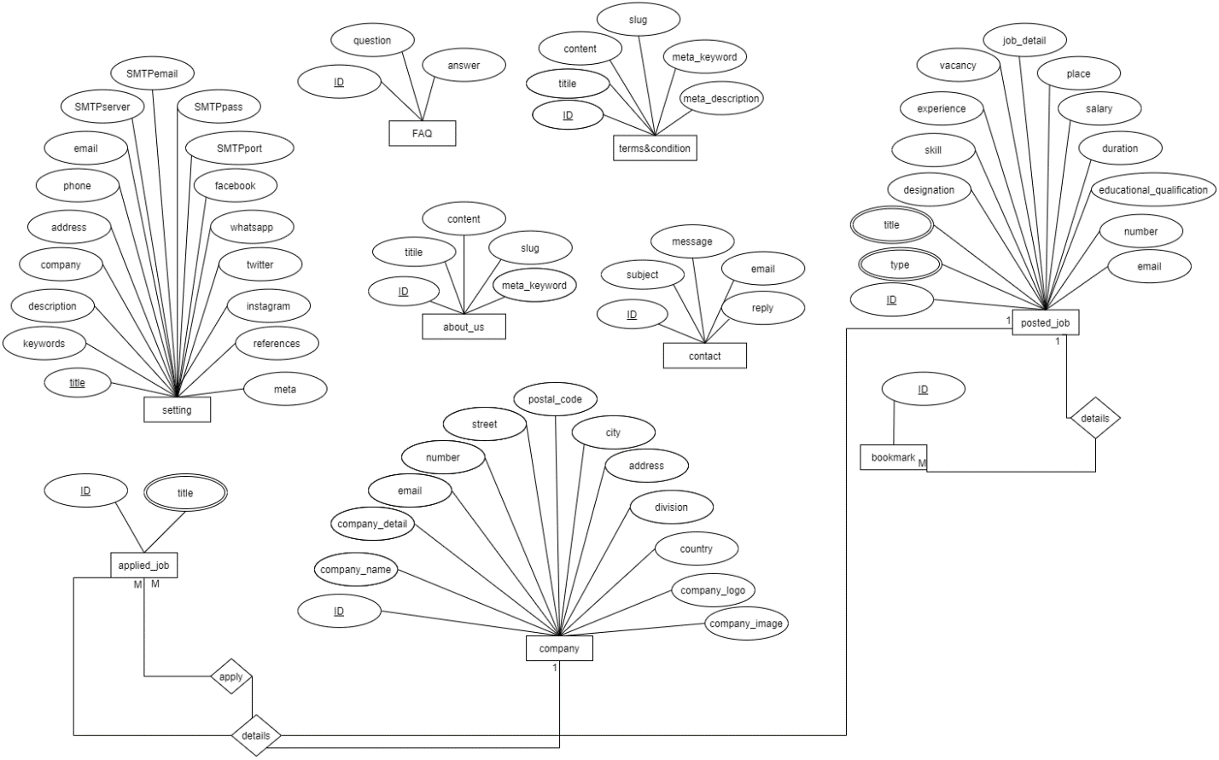

**Figure:** Entity Relationship Diagram(part-3)

# CHAPTER 4: System Testing

# Introduction

This website is built for public purpose. Several types of users can use this system with many facilities. For maintaining standard quality, various kind of testing process is required. Such as-

* Functional Testing
* Unit Testing
* Integration Testing
* System Testing
* Acceptance Testing

# Feature to be Tested

|  |  |  |  |
| --- | --- | --- | --- |
| Number | Title | Description | Priority |
|  | Sign up | If user wants to manage site, then user has to register first | High |
|  | Sign in | If user is registered then he/she can sign in to access the features | High |
|  | Post job | Verified companies or project manager can post jobs or projects. | High |
|  | Manage Profile | User can manage its profile with proper info | High |
|  | Apply job | Verified applicant can apply for suitable jobs or projects | High |
|  | Create community | New community can be created to discuss on several topic | Medium |
|  | Logout | The session must be destroyed after logout | High |

# Test Case

## Sign up

|  |  |  |  |  |  |  |
| --- | --- | --- | --- | --- | --- | --- |
| TC-1 | Sign up | | | | | |
| Test  Sl no. | Description | Input | Output | Expected output | Status | comment | |
| 1 | Using new email | Type(applicant)  Email([xyz@gmail.com](mailto:xyz@gmail.com))  Username(xyz)  Password(123) | Success Response | Success Response | Pass |  | |
| 2 | Using used email | Type(applicant)  Email([xyz@gmail.com](mailto:xyz@gmail.com))  Username(xyz)  Password(123) | Error Response | Error Response | pass |  | |

## Sign in

|  |  |  |  |  |  |  |
| --- | --- | --- | --- | --- | --- | --- |
| TC-2 | Sign in | | | | | |
| Test  Sl no. | Description | Input | Output | Expected output | Status | comment | |
| 1 | Using Invalid credentials | Type(applicant)  Email([xyz@gmail.com](mailto:xyz@gmail.com))  Username(xyz)  Password(123) | Error Response | Error Response | Pass |  | |
| 2 | Using valid credential | Type(applicant)  Email([xyz@gmail.com](mailto:xyz@gmail.com))  Username(xyz)  Password(123) | Success Response | Success Response | pass |  | |

## Post job

|  |  |  |  |  |  |  |
| --- | --- | --- | --- | --- | --- | --- |
| TC-3 | Post job | | | | | |
| Test  Sl no. | Description | Input | Output | Expected output | Status | comment | |
| 1 | Using Invalid info | Title(xyz)  Description(xyz)  Company(xyz)  Salaray(123450) | Invalid Response | Invalid Response | Pass | Unverified | |
| 2 | Using valid info | Title(xyz)  Description(xyz)  Company(xyz)  Salaray(123450) | Success Response | Success Response | pass | Verified | |

## Manage Profile

|  |  |  |  |  |  |  |
| --- | --- | --- | --- | --- | --- | --- |
| TC-3 | Manage profile | | | | | |
| Test  Sl no. | Description | Input | Output | Expected output | Status | comment | |
| 1 | Fill up all info incorrectly | Full name(xyz)  Description(xyz)  Qualification(xyz)  Experience(5 years) | Success Response | Invalid Response | Pass | Unverified | |
| 2 | Fill up all info correctly | Full name(xyz)  Description(xyz)  Qualification(xyz)  Experience(5 years) | Success Response | Success Response | pass | Verified | |

## Apply job

|  |  |  |  |  |  |  |
| --- | --- | --- | --- | --- | --- | --- |
| TC-3 | Apply job | | | | | |
| Test  Sl no. | Description | Input | Output | Expected output | Status | comment |
| 1 | Using Invalid info | Title(xyz)  Description(xyz)  Company(xyz)  Salaray(123450) | Invalid Response | Invalid Response | Pass |  |
| 2 | Using valid info | Title(xyz)  Description(xyz)  Company(xyz)  Salaray(123450) | Success Response | Success Response | pass |  |

## Create community

|  |  |  |  |  |  |  |
| --- | --- | --- | --- | --- | --- | --- |
| TC-2 | Create community | | | | | |
| Test  Sl no. | Description | Input | Output | Expected output | Status | comment | |
| 1 | Input valid credential | Name(xyz)  Invit-link([www.xyz.com](http://www.xyz.com))  Topic(xyzabc) | Success Response | Success Response | Pass |  | |
| 2 | Input valid credential/miss any field | Name(xyz)  Invit-link()  Topic() | Invalid Response | Invalid Response | pass |  | |

## Log out

|  |  |  |  |  |  |  |
| --- | --- | --- | --- | --- | --- | --- |
| TC-2 | Log out | | | | | |
| Test  Sl no. | Description | Input | Output | Expected output | Status | comment | |
| 1 | Must be Logged in state and visit logged out url | NULL | Success Response | Success Response | Pass |  | |
| 2 | Not logged in state and visit on logged out url | NULL | Invalid Response | Invalid Response | pass |  | |

# Chapter 5: Application UI & User Manual

* 1. Authentication

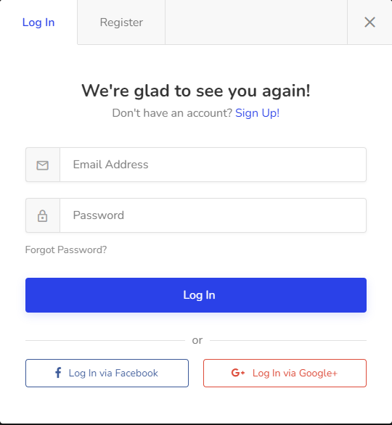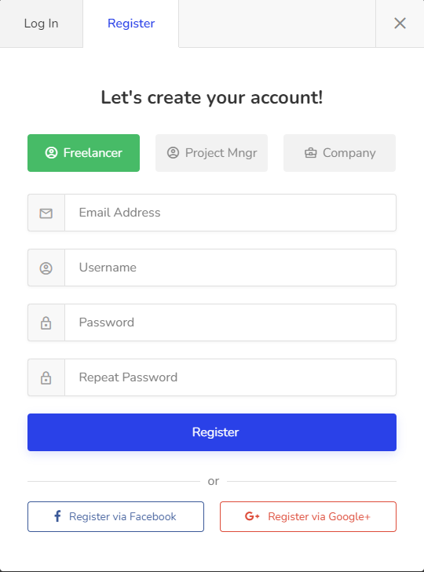

# Landing page

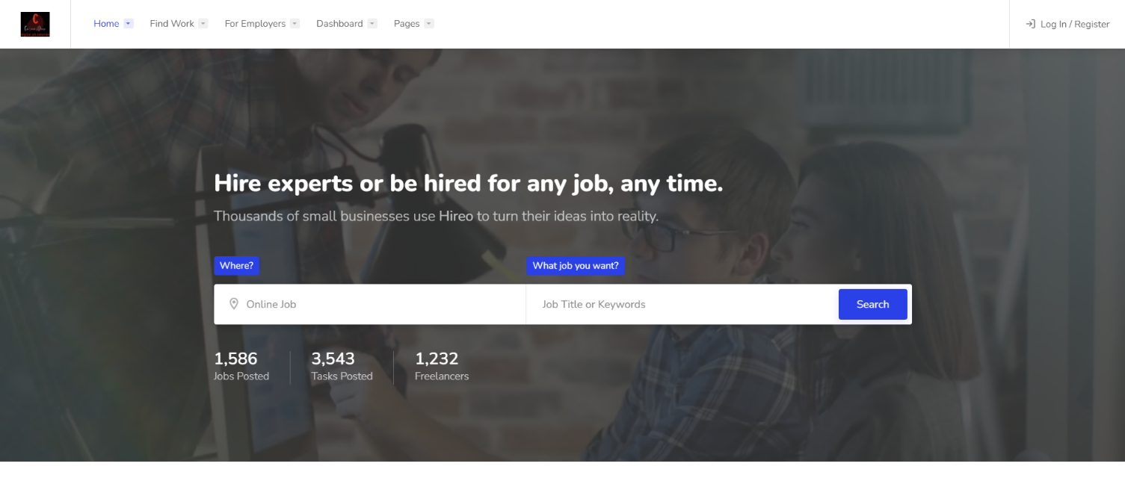

# Popular categories

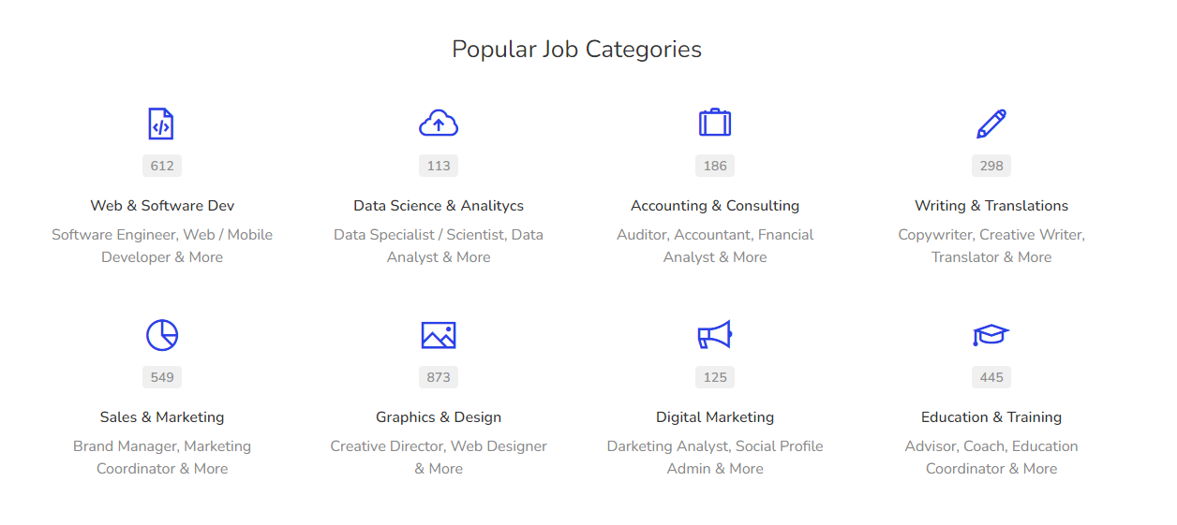

# Featured Jobs

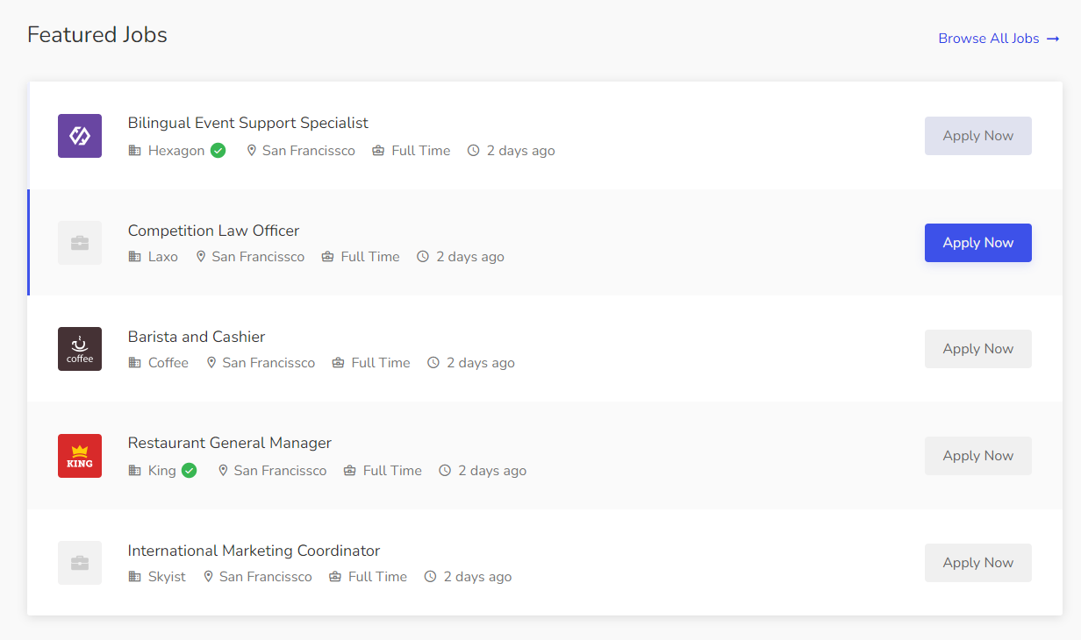

# Post a job

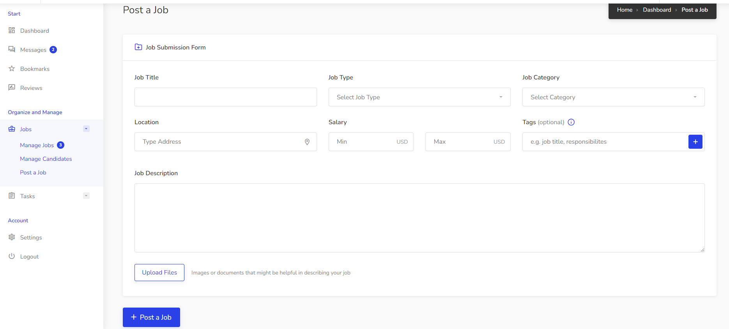

# Job list

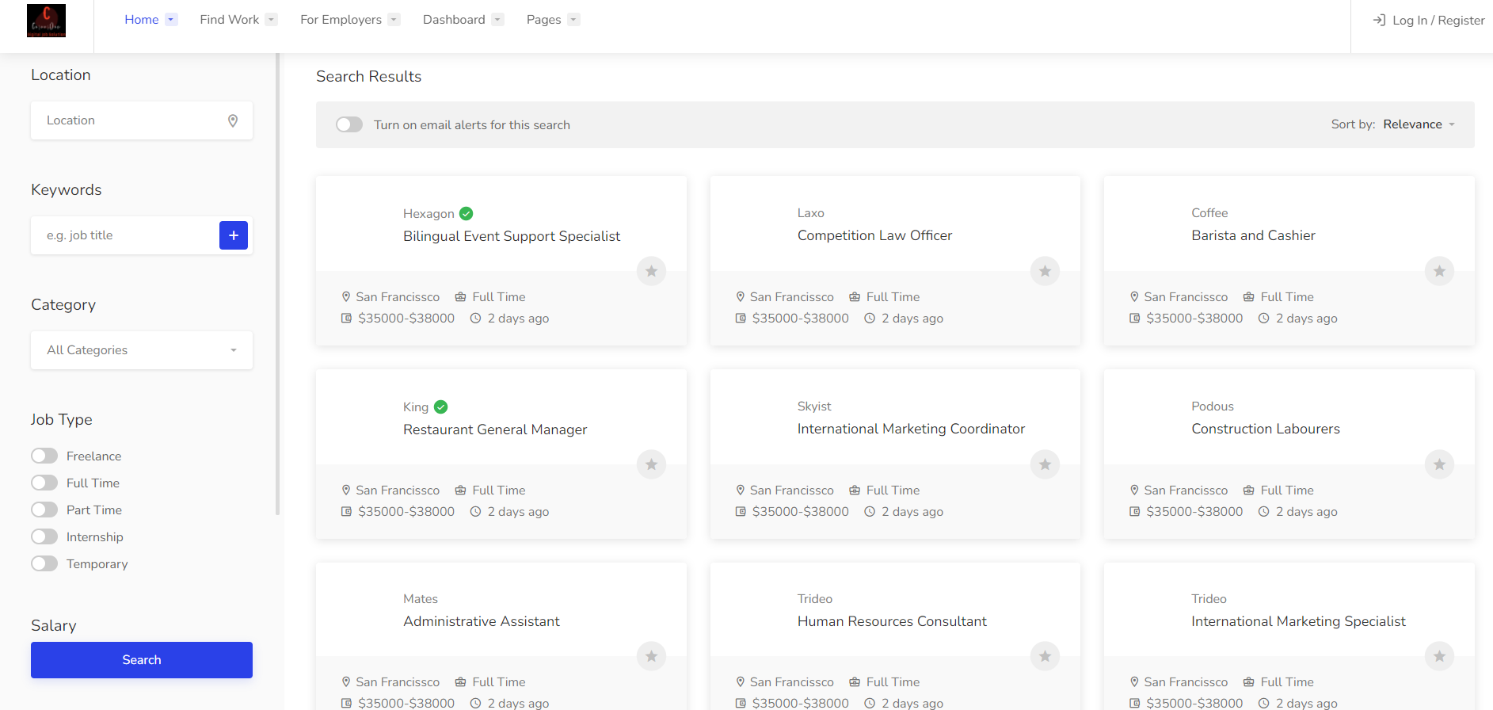

# Live messaging

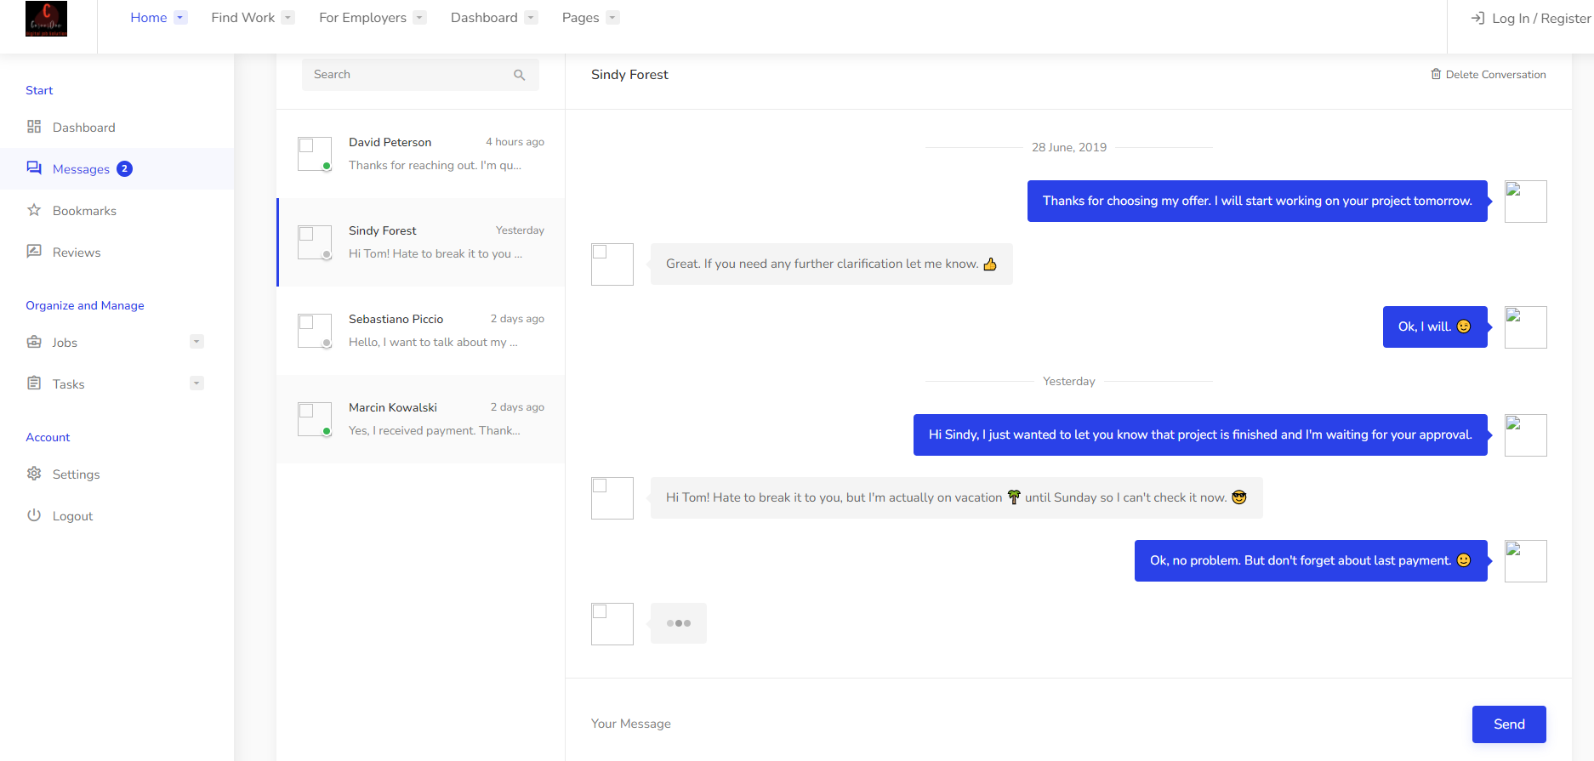

# Chapter 6: Conclusion

## Limitations

The main limitation of this application is optimization. If day after day the database size may become larger and this could be a issue with optimization and also some security issue may endanger this application.

## Obstacles

* Learning new technology and new environment is a big issue
* Single handed work was not enough to do this project
* It’s very difficult to complete a project like this huge is a great issue
* To collect requirements is very tough one that I did

## Achievement

* Successfully built a project.
* Learnt a new technology.
* Deploy a project is a new experience.
* Learned the real-life experience by uploading project on the live server.
* Know about document and the development process.

## Future Scope

Though the system was developed as much as needed and its work properly. But I have to add something features to make the systems fulfillment. The future work will include some major changes, such as-

* Online meeting
* Community discussion
* Work bidding system
* Emailing every confirmation

## Reference

To work with this project I have studied over some website to learn their facilities and limitations. My target is to provide something newer which can help every day life. But I want to give a great credit to these web application-

### Upwork

* Name: Upwork
* Visit: [www.upwork.com](https://www.upwork.com/)
* Company: Upwork Global Inc.
* Country: California, U.S

### Fiverr

* Name: Fiverr
* Visit: [www.fiverr.com](https://www.fiverr.com/)
* Company: Fiverr International Ltd.
* Country: Israel

### PeoplePerHour

* Name: PeoplePerHour
* Visit: [www.peopleperhour.com](https://www.peopleperhour.com/)
* Company: PeoplePerHour
* Country: UK

## Naukri.com

* Name: Naukri.com
* Visit: [www.naukri.com](https://www.naukri.com/)
* Company: Naukri.com
* Country: India

### Bdjobs.com

* Name: Bdjobs.com
* Visit: [www.bdjobs.com](https://www.bdjobs.com/)
* Company: Bdjobs.com Ltd.
* Country: Bangladesh